Residents of Paradise and Swall Meadows, please join us for an open house on the 2015 Regional Transportation Plan and General Plan update.

**6:00 PM Wednesday, September 16, 2015**

**Paradise Fire House**

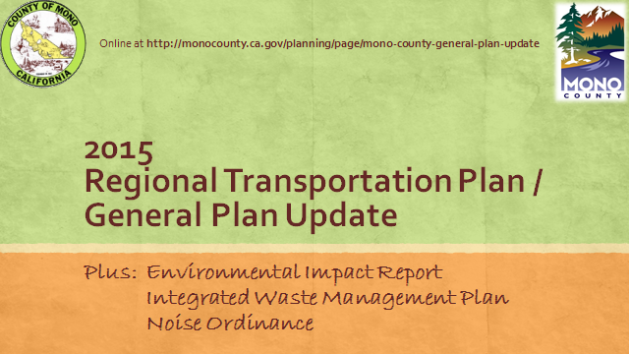

Questions? Please contact Gerry Le Francois at 760.924.1810, [glefrancois@mono.ca.gov](mailto:glefrancois@mono.ca.gov) or Wendy Sugimura at 760.924.1814, [wsugimura@mono.ca.gov](mailto:wsugimura@mono.ca.gov)