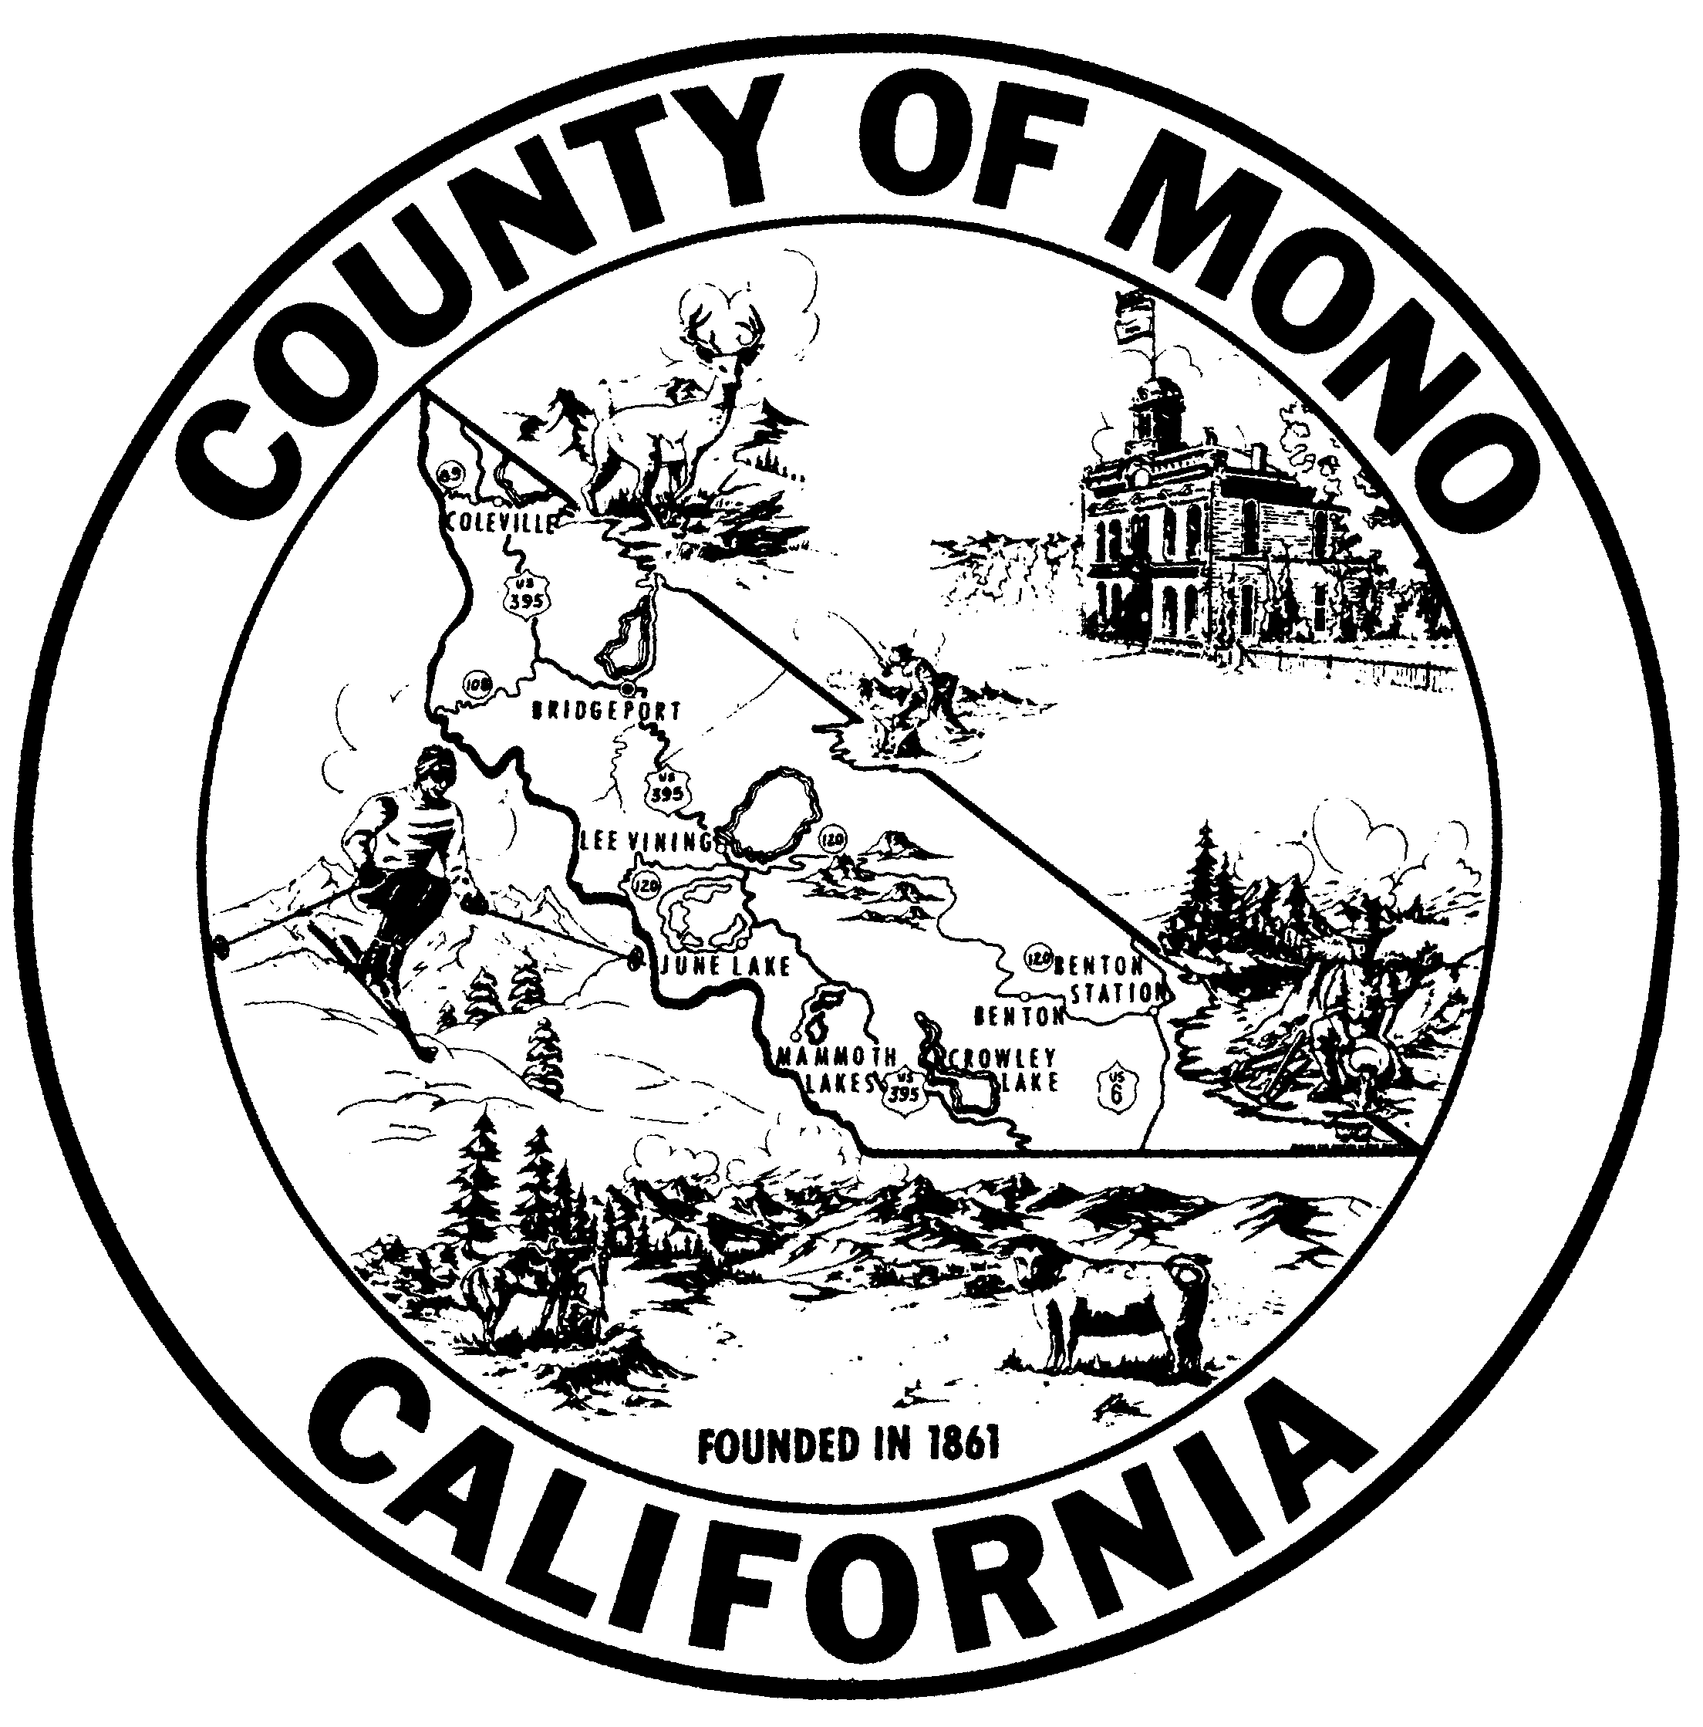 | MONO COUNTY PROBATION DEPARTMENT  Mailing: P.O. Box 596, Bridgeport, California 93517  BRIDGEPORT OFFICE (760) 932-5570•FAX (760) 932-5571  MAMMOTH OFFICE (760) 924-1730•FAX (760) 924-1731  probation@mono.ca.gov
Karin Humiston, Ph.D.  Chief Probation Officer |  |  | April 14, 2023

PRESS RELEASE

Mono County Probation Services is pleased to announce being a recipient of the Public Health and Safety Grant Program, awarded by the Board of State and Community Corrections (BSCC).

Proposition 64 legalized adult use of marijuana and established that a portion of the tax revenues from sales would come to the BSCC as the Public Health and Safety Grant Program. The five-year grants are for mitigations such as eradicating illegal grows, compliance monitoring, environmental remediation, and substance-use prevention. The Board awarded $93.7million of $150 million available to the 39 jurisdictions whose applications met grant criteria.

Mono County was awarded $2,767,916, with the Lead Public Agency as Mono County Probation Department. This award will be applied to the Mono County Mammoth High School Safety Program (MHSSP). This program targets the need for youth cannabis and substance use prevention and intervention programs; education outlining health impacts of youth cannabis use for high school students and young adults (18-21 year olds); a safe environment with caring adults after school (3:00 pm – 6:00 pm) for academics, recreation, and program intervention; and provides objective evaluation of efficacy of programs on reduction of youth referrals for cannabis use. Mono County will enter a Memorandum of Understanding (MOU) with the Mammoth Unified School District (MUSD) for time and location with Law Related Education and officer presence.

