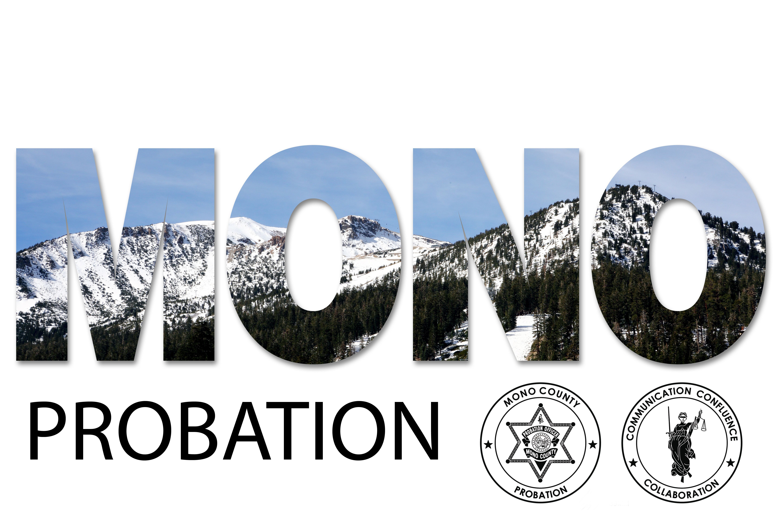 | Mailing: P.O. Box 596, Bridgeport, California 93517  BRIDGEPORT OFFICE (760) 932-5570•FAX (760) 932-5571  MAMMOTH OFFICE (760) 924 1730•FAX (760) 924-1731
Mark Magit
Presiding Judge
Superior Court
Dr. Karin Humiston
Chief Probation Officer

July 20, 2021

Amanda Wagner, Deputy Probation Officer III
PO Box 596
Bridgeport, CA 93517

Dear Officer Wagner,
Each year during Pretrial, Probation and Parole week, an outstanding Mono County Probation employee is recognized for their work in the field of probation. It is with great pleasure to recognize you as this years’ Probation Employee of the Year.

This year brought challenges and the need for innovation. The pandemic changed how we implemented probation and demonstrated a need to still make meaningful contact with our clients. You have shown that your experience and knowledge is a significant asset to the department. Your ability to step into complex situations or roles and handle them with ease has been recognized by your peers, supervisors, and justice partners.

The Walker community was devastated on November 17, 2020, by the Mountain View Fire which destroyed 96 homes and displaced many families. You volunteered to assist families at the evacuation shelter in Carson Valley Inn in Minden, Nevada. Your desire to help coupled with your kindness and knowledge of support through your experience as a Peer Support Officer assisted many families through this traumatic time. On July 6, 2021, the Board of Supervisors received a letter from a Walker Community member identifying you and your coworkers as being very helpful saying “We commend the kind and compassionate help that was given to us by Kyla and Cassidy from Social Services and by Amanda Wagner and Erin Van Kampen.” Your kindness assisted this family in their initial shock and needs during this traumatic incident.

The COVID 19 Pandemic has been a challenge worldwide and more specifically, our clients who struggled with isolation at such a young age. You, along with the Juvenile Division, worked diligently to maintain contact and ensure services were provided. Those youth who failed to attend online school were brought to Probation’s office to participate. You recognized the importance of inclusivity and education and collaboratively designed a Law Day for Mammoth Lakes students. The Law Day event delivered two scholarships to youth through donations. Considering the restrictions of the pandemic, Law Day occurred on Mono County Probation’s Facebook Live site with over two hundred visitors. Also critical to achieving the mission of the Juvenile Division, your assistance in the development of the Proposition 64 grant for an Afterschool Program was significant. In the absence of your supervisor, your input and evaluation allowed Probation to meaningfully collaborate with the Mammoth Lakes Unified School District to provide direct services to youth in the High and Middle School.

Along with your assigned duties, you acted as the Deputy Probation Officer V, Manager, during the absence of your supervisor from November 16, 2020 to February 8, 2021. Your duties fell within the Job Description of Deputy Probation Officer V Manager as listed within the Mono County Human Resource Job Description. You completed those duties thoughtfully and your decisions were logical. It was a pleasure to work with you, as the two managers work closely with the Chief of Probation, with your attention to detail and completion of tasks were most appreciated.

Once again, congratulations on receiving this award and for your passion and service to this County.

Sincerely,

K.S. Humiston

