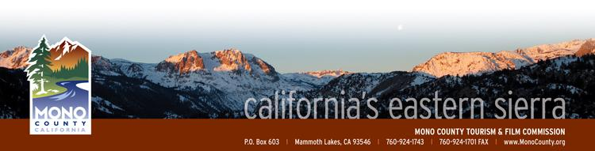

Mono County Tourism/Film Commission

Post Office Box 603
Mammoth Lakes CA 93546
760.924.1743 * 760.924.1697 (fax)
MonoCounty.org

MINUTES

SPECIAL MEETING of TUESDAY June 24th, 2014
10:00 am

Lee Vining Community Center
296 Mattley Avenue
Lee Vining, CA 93541

Attending: Bill Banta, Jennifer Roeser, Michael Vanderhurst, Andrew Jones
Absent: Jimmy Little, Chris Long, Steve Morrison
Staff: Alicia Vennos, Jeff Simpson
Other: Ted Carleton, Jeff Hunter, George Shirk
- Call to Order. 10:07 am
- Introductions and announcements. Introductions were made by Commissioners for the visiting presenters and attending media.
- Opportunity for the Public to Address the Commission on items of interest of the public which are within the subject matter jurisdiction of the Commission. Mr. Simpson gave a brief update on the Special Board meeting regarding Conway Ranch to be held in Lee Vining on Friday, June 27th. Mr. Simpson also covered stocking schedule and updates.
- Approval of the Minutes of March 25th, 2014 regular meeting. A MOTION WAS MADE BY VANDERHURST, SECONDED BY ROESER TO APPROVE THE MINUTES OF THE MAY 15th, 2014 SPECIAL MEETING. MOTION APPROVED 4-0, NO ABSTENTIONS.
- Commissioner Reports. Mr. Vanderhurst reported on the recent Society of American Travel Writers (SATW) conference and its success. Ms. Roeser reported that The Discovery Channel will be filming at McGee Creek Pack Station. Mr. Jones reported on the grand opening of June Lake Brewing as well as a Ford commercial filming in June Lake, and journalist Mimi Slawoff’s article on family-friendly June Lake.

- Eastern Sierra Fishing Guidebook. Ted Carleton presented information on an Eastern Sierra Fly Fishing Guide Book that will be written and published by a fishing guide/writer who lived for some years in the Eastern Sierra. The Commission offered positive feedback and recommended that Mr. Carleton meet with the Fisheries Commission for potential sponsorship.

- Bodie Hills Monument Presentation & Discussion. Mr. Hunter presented and discussed the process for the Bodie Hills to be designated a Bureau of Land Management National Monument. The Commission encouraged Mr. Hunter to expand his community outreach.

- Mono County Contingency Plan/Plan “B”. Commissioners discussed ways in which the county might work more closely with Caltrans and Yosemite National Park to establish criteria regarding road closures in advance of future crisis scenarios like winter drought, lengthy wildfires, and other issues affecting visitor/resident access.

- Monthly Financial/ Budget Report. Ms. Vennos reported on the budget workshop with the Board of Supervisors, and next steps in the budget process and adoption.

- Film Commission: Ms. Vennos is attending the Film Liaisons in California (FLICS) quarterly meeting and Locations Conference in Los Angeles, June25/26. The new Film Commission Website (www.FilmMonoCounty.com) is up and running with minor adjustments still being made to fine-tune the overall cohesiveness and accessibility of the website.
- Data Collection for presentations. Ms. Vennos plans to organize a meeting of permit coordinators from the various land use management agencies/Town of Mammoth Lakes to discuss current permitting processes and data tracking.
- ACTION: Commission to consider approval of a Letter of Support for AB 1839 - Expansion of the California Film & Television Production Tax Credit. A MOTION WAS MADE BY VANDERHURST, SECONDED BY ROESER TO APPROVE A LETTER OF SUPPORT TO THE SENATE COMMITTEE FOR GOVERNANCE AND FINANCE FOR AB 1839. MOTION APPROVED 4-0, NO ABSTENTIONS.

- Project Update: Mr. Simpson gave an update on the tourism website’s Booking.com statistics since May 1, 2014. Mr. Simpson also reported on positive Social Media results – the Tourism Facebook page now has over 21,000 fans.

- Economic Development: Ms. Vennos and Mr. Simpson shared the Economic Development/Tourism PowerPoint which they are presenting to all the community RPAC groups.

- Call for Agenda items for next regular meeting. None.

- Adjourn the meeting and reconvene in regular session on Tuesday, July 22nd, 2014 at 10:00 a.m. in Bridgeport, California (location TBD).
