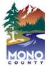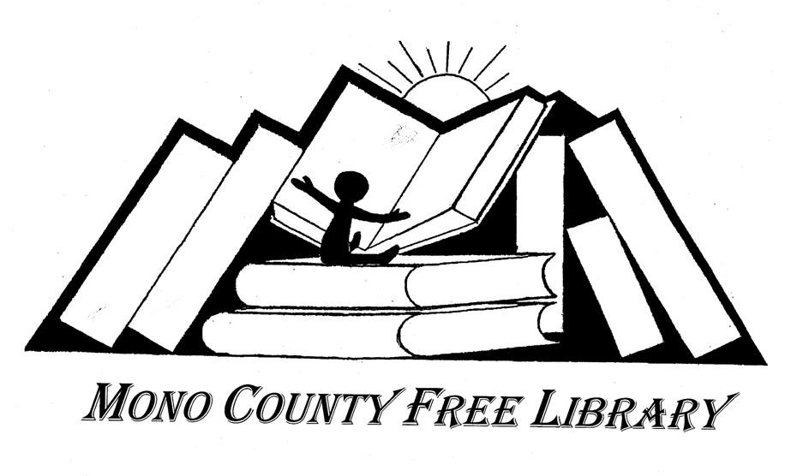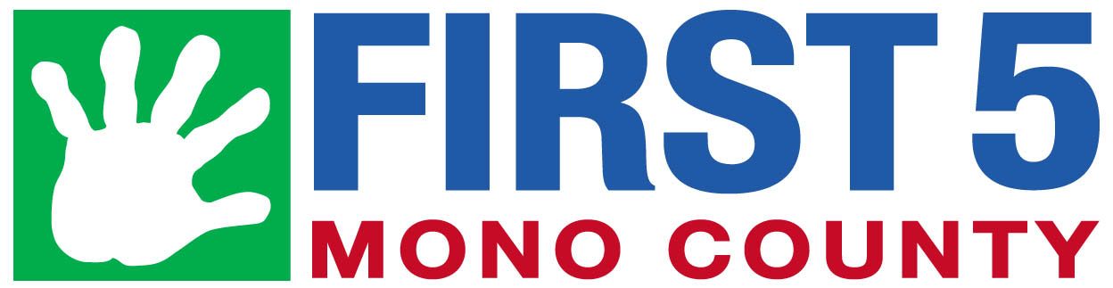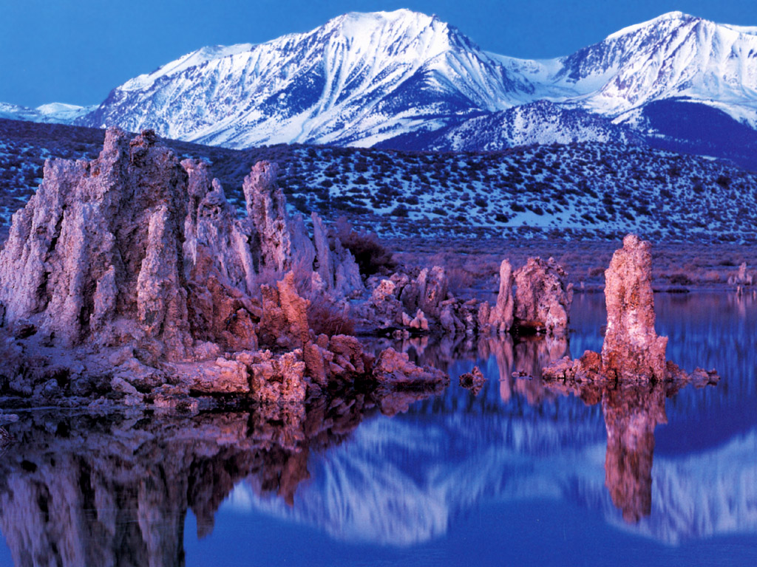

Mono County Child Abuse Prevention Council (CAPC)

www.mono.ca.gov/capc

Updated July 1, 2020 Revisado 1 de July, 2020

2020-2021

Mono County Community Resource Guide

Guía de Recursos Comunitarios de Mono County

Strengthening Families with the 5 Protective Factors

1. Resilience

Resilience is the ability to bounce back from all types of challenges. It means finding ways to solve problems, building and sustaining trusting relationships, taking care of you, and knowing it is OK to seek help when necessary.

1. Social Connections

Everyone needs to feel cared for and connected. Friends, family members, neighbors and community members provide emotional support, help solve problems, offer insights and give concrete assistance.

1. Knowledge of Parenting & Child Development

Being a good parent is part natural and part learned. Parents, who understand child development, are responsive to their child’s needs and practice positive parenting strategies will feel more engaged and empowered. Kids thrive in an environment that fosters secure attachments and healthy development.

1. Concrete Support in Times of Need

Everyone faces challenging times. It is important to know where to access support services and that it is OK to ask for help.

1. Teach Children Social and Emotional Competence

Be a good role model. Teach children to communicate clearly and express their feelings effectively. Help them learn how to be a good friend. A child/youth who is able to interact positively with others, self-regulate their behavior and effectively communicate their feelings will be able to build and sustain healthy relationships throughout their lifetime.

**For More Information on the**

**5 Protective Factors visit**

**The Center of the Study of Social Policy**

[**http://www.cssp.org/reform/strengtheningfamilies**](http://www.cssp.org/reform/strengtheningfamilies)

“Like” or “Friend” us at

Mono Strengthening Families/Facebook

Fortaleciendo Familias con los

5 Factores de Protección

1. Resiliencia

Resiliencia es la habilidad de recuperarse de todo tipo de desafíos. Significa encontrar maneras de resolver problemas, desarrollar y mantener relaciones de confianza, cuidar de si mismo, y saber que está bien buscar ayuda cuando sea necesario.

1. Conexiones sociales

Todo el mundo necesita sentirse querido y conectado. Amigos, miembros de la familia, vecinos y miembros de la comunidad proveen apoyo emocional, ayudan a resolver problemas, ofrecen entendimiento y dan asistencia concreta.

1. Conocimiento de la crianza del niño y del desarrollo del niño

Ser un buen padre es una habilidad en parte natural y en parte aprendida. Aquellos padres que entienden los principios del desarrollo del niño, responden a las necesidades del niño y practican estrategias de crianza positivas se sentirán más comprometidos y fortalecidos. Los niños progresan en un ambiente que fomenta apego seguro y desarrollo saludable.

1. Apoyo concreto en momentos de necesidad

Todo el mundo enfrenta momentos difíciles. Es importante saber dónde encontrar servicios de apoyo y que está bien pedir ayuda.

1. Enseñe competencia social y emocional a los niños

Sea un buen ejemplo. Enseñe a los niños a comunicarse claramente y a expresar efectivamente sus sentimientos. Ayúdelos a aprender ser un buen amigo. Un niño quien puede interactuar positivamente con otros, auto-regular su comportamiento y comunicar efectivamente sus sentimientos podrá desarrollar y mantener relaciones saludables a través de su vida.

**Para más información acerca de los 5 Factores de Protección visite el Centro de Estudios sobre Política Social**

[**http://www.cssp.org/reform/strengtheningfamilies**](http://www.cssp.org/reform/strengtheningfamilies)

“Like” or “Friend” us at

Mono Strengthening Families/Facebook

**EMERGENCY SERVICES/SERVICIOS DE EMERGENCIA**

Fire, Ambulance, Sheriff’s, California Highway Patrol 911

Mammoth Hospital–Emergency Department 760-934-3311

Mono County Sheriff’s Dispatch 760-932-7549

**LAW ENFORCEMENT/ORDEN PÚBLICO**

California Highway Patrol 760-932-7995

Mammoth Lake Police Department 760-965-3700

Mono County Animal Control 760-932-5630

Mono County Probation, Bridgeport 760-932-5570

Mono County Probation, Mammoth Lakes 760-932-1730

Mono County Sheriff’s Department 760-932-7549

**FIRE DEPARTMENTS/DEPARTAMENTO DE BOMBEROS**

Antelope Valley 530-495-2900

Benton 760-933-2252

Bridgeport 760-932-7353

June Lake 760-648-7390

Lee Vining 760-647-6400

Long Valley 760-935-4545

Mammoth Lakes 760-934-2300

**24-HOUR HOTLINES/TELÉFONOS DE EMERGENCIAS**

California Youth Crisis Line 800-843-5200

Child Abuse Hotline 800-422-4453

Child Abuse – To Report Localy 800-340-5411

Mono County Behavioral Health Access Line 800-687-1101

National Domestic Violence Hotline 800-799-7233

National Drug & Alcohol Treatment 800-622-2255

National Parent Support Line 855-427-2736

National Sexual Assault Hotline 800-656-4673

Suicide Prevention Lifeline 800-273-8255

Wild Iris Crisis Line 877-873-7384

**HOSPITALS/HEALTH CLINICS**

**HOSPITALES/CLINICAS DE SALUD**

Mammoth Hospital & Clinics 760-934-3311

Mono County Public Health, Bridgeport 760-932-5580

Mono County Public Health, Mammoth 760-924-1830

Toiyabe Indian Health Project 530-495-2100

**HEALTH INSURANCE ASSISTANCE**

**ASISTENCIA CON SEGURO DE SALUD**

Covered California Enroll Online http://www.coveredca.com

Mono County Department of Social Services 760-924-1770

**SUBSTANCE ABUSE PREVENTION & TREATMENT**

**PREVENCION Y TRATAMIENTO PARA ABUSO DE SUBSTANCIAS**

Alcoholics Anonymous, Alanon & Alateen 800-851-1304

California Smokers Helpline 800-662-8887

Mono County Behavioral Health 760-924-1740

**COUNSELING/SERVICIOS DE TERAPÍA Y ORIENTACIÓN**

Mono County Behavioral Health 760-924-1740

North Star Counseling Center 760-924-7926

Wild Iris 760-934-2491

**FINANCIAL, FOOD &/or CLOTHING**

**FINANCIAMIENTO, ALIMENTACION y/o ROPA**

Antelope Valley Senior Center, Walker 530-495-2323

IMACA 760-934-3343

Mono County Department of Social Services 760-924-1770

Salvation Army Food Pantry 220 Sierra Manor 760-872-2124

Wild Iris 760-934-2491

SHINE 760-648-3075

**HOUSING &/or ENERGY ASSISTANCE**

**ASISTENCIA de VIVIENDA y/o ENERGIA**

IMACA 760-934-3343

Mammoth Lakes Housing 760-934-4740

Mono County Department of Social Services 760-924-1770

Wild Iris 760-934-2491

SHINE 760-648-3075

**DEVELOPMENTAL SCREENINGS (AGES 0-3 years)/**

**REVISIÓN DE DESARROLLO (Edades 0-3 años)**

First 5 Mono 760-924-7626

Great Steps Ahead 760-872-2270

Kern Regional Center 760-873-7411

MCOE/Early Start 760-934-0031

Sierra Park Pediatric Clinic 760-924-4000

**SPECIAL EDUCATION (AGES 3-21 years)/**

**EDUCACIÓN ESPECIAL (Edades 3-21 años)**

MCOE/Pre-K (Ages 3-5) 760-934-0031

Contact School of Attendance (Ages 5-21) -SCHOOLS/ESCUELAS

**DISABILITY ASSISTANCE/ASISTENCIA POR DISCAPACIDAD**

Community Services Solutions 530-495-2700

Disabled Sports of the Eastern Sierra 760-934-0791

Disability Rights – Advocacy 800-776-5746

Mono County Department of Social Services 760-924-1770

**ELDERLY ASSISTANCE &/or SENIOR PROGRAMS/ ASISTENCIA A LA TERCERA EDAD Y/o PROGRAMAS PARA ANCIANOS**

Antelope Valley Senior Center 530-495-2323

Community Services Solutions 530-495-2700

Eastern Sierra Area Agency on Aging 877-462-2298

Mono County Department of Social Services 760-924-1770

**NATIVE AMERICAN TRIBES/TRIBUS NATIVO AMERICANAS**

Bridgeport Indian Colony 760-932-7083

Mono Lake Kutzadika 760-605-6263

Utu Utu Gwaitu Paiute Tribe Benton 760-933-2321

**ADDITIONAL NATIVE AMERICAN RESOURCES/**

**RECURSOS NATIVO AMERICANOS ADICIONALES**

Bishop Paiute Tribe 760-873-4477

Owens Valley Career Development Center

Benton Tribal TANF 760-933-2426

Coleville Tribal TANF 530-495-1000

Toiyabe Indian Health Project 760-873-8461

**LEGAL SERVICES/SERVICIOS LEGALES**

Mono County Child Support Services 866-901-3212

Mono County District Attorney 760-932-5550

Mono County Probation, Bridgeport 760-932- 5570

Mono County Probation, Mammoth Lakes 760-932-1730

Mono County Recorder 760-932-5530

Mono County Superior Court 760-924-5444

Self-help & Family Law Assistance 760-258-7372

**TRANSPORTATION/TRANSPORTE**

California Road Conditions 800-427-7623

Dial-a-Ride (Mammoth Lakes Only) 760-924-3184

Eastern Sierra Transit 760-872-1901

**RECREATION/RECREACIÓN**

Mammoth Lakes Welcome Center 760-924-5500

June Mountain Ski Area 760-648-7733

Mammoth Mountain Ski Area 760-934-2571

Town of Mammoth Lakes, Recreation 760-965-3690

**VETERAN SERVICES/SERVICIOS PARA VETERANOS**

County of Inyo-Mono Veteran Services 760-873-7850

**WELLNESS PROGRAMS/PROGRAMAS DE SALUD**

Mammoth Hospital 760-934-3311

Mono County Behavioral Health 760-924-1740

Toiyabe Indian Health Community Wellness 760-873-8851

**COUNTY & TOWN OF MAMMOTH LAKES GOVERNMENT/ GOBIERNO DEL CONDADO Y PUEBLO DE MAMMOTH LAKES**

Mammoth Lakes Town Council/Clerk 760-965-3600

Mono County Board of Supervisors/Clerk 760-932-5530

**ADDITIONAL COUNTY & TOWN OF MAMMOTH LAKES BOARDS & COUNCILS/JUNTAS Y CONSEJOS ADICIONALES DEL CONDADO Y PUEBLO DE MAMMOTH LAKES**

http://www.ci.mammoth-lakes.ca.us

http://www.mono.ca.gov/boards

**NEW PARENT SUPPORTS**

**APOYO PARA PADRES PRIMERIZOS**

First 5 Mono 760-924-7626

Mono County Child Care Council 760-934-3343

Mono County Public Health, Bridgeport 760-932-5580

Mono County Public Health, Mammoth 760-924-1830

Mono County Resource & Referral 760-934-3343

Sierra Park Pediatric Clinic 760-924-4000

Women, Infant and Children (WIC) 760-924-4610

**PARENT EDUCATIÓN/EDUCACION PARA PADRES**

Car Seat Checks

CHP, Bridgeport 760-932-7995

Mammoth Lakes Police Department 760-965-3700

First 5 Mono 760-924-7626

MCOE/Adult Education 760-934-0031

**EARLY CHILDHOOD RESOURCES**

**RECURSOS PARA LA NIÑEZ TEMPRANA**

First 5 Mono 760-924-7626

Mono County Child Care Council 760-934-0031

Mono County Libraries & Raising-a-Reader 760-934-8670

Mono County Public Health, Bridgeport 760-932-5580

Mono County Public Health, Mammoth 760-924-1830

Mono County Resource & Referral (IMACA CCCC) 760-934-3343

Sierra Park Pediatric Clinic 760-924-4000

Women, Infant and Children (WIC) 760-924-4610

**CHILD CARE CENTERS/PRESCHOOLS**

**CENTROS PREESCOLARES Y DE CUIDADO DEL NIÑO**

Bridgeport Preschool 760-932-7443

IMACA Head Start & CA State Preschools 760-934-3343

(Mammoth Lakes, Lee Vining & Coleville)

IMACA for a list of Family Childcare Providers 760-934-3343

Kids Corner 760-934-4700

Mammoth Lutheran Preschool 760-934-4051

Mono County Office of Education 760-934-0031

**SCHOOL DISTRICTS & SCHOOLS/DISTRITOS (K-12) ESCOLARES Y ESCUELAS (K-12)**

Eastern Sierra Unified School District Office 760-932-7443

Antelope Valley Elementary School 530-495-2541

Bridgeport Elementary School 760-932-7441

Coleville High School 530-495-2231

Edna Beaman Elementary School 760-933-2397

Lee Vining Elementary School 760-647-6460

Lee Vining High School 760-647-6366

Mammoth Unified School District Office 760-934-6802

Mammoth Elementary School 760-934-7545

Mammoth High School 760-934-8541

Mammoth Middle School 760-934-7072

Mono County Office of Education (MCOE) 760-934-0031

**LIBRARIES/BIBLIOTECAS**

Mono County Library Administration 760-934-8670

Benton 760-933-2542

Bridgeport 760-932-7482

Coleville 530-495-2295

Crowley Lake 760-935-4505

June Lake 760-648-7284

Lee Vining 760-647-6123

Mammoth Lakes 760-934-4777

**HIGHER EDUCATION/EDUCACIÓN SUPERIOR**

Cerro Coso Community College 760-934-2875

MCOE/Adult Education 760-934-0031

**JOB SERVICES/SERVICIOS DE TRABAJO**

Mono County Department of Social Services 760-924-1770

SHINE 760-648-3075