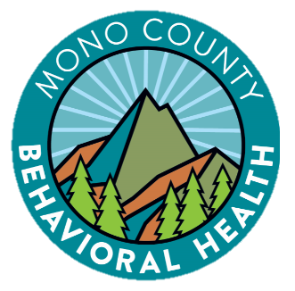

Mono County
Behavioral Health

Cultural and Linguistic Competence Plan
2020

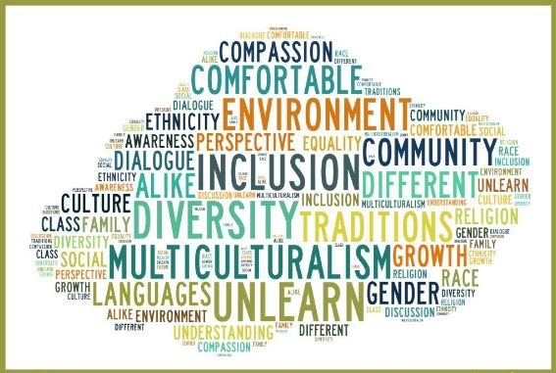

Contents
Overview 4
Criterion 1: Commitment to Cultural and Linguistic Competence 5
I. County mental health commitment to cultural competence 5
II. County recognition, value, and inclusion of racial ethnic, cultural, and linguistic diversity within the system 6
III. County designated Cultural Competence/Ethnic Services Manager (CC/ESM) person 6
IV. Budget resources targeted for culturally competent activities 7
Criterion 2: Updated Assessment of Service Needs 7
I. General Population 7
II. Medi-Cal Population Service Needs 10
III. 200% of Poverty (minus Medi-Cal) population and service needs 13
IV. MHSA Community Services and Supports (CSS) population assessment and service needs 13
V. Prevention and Early Intervention (PEI) Plan: The process used to identify the PEI priority populations 13
Criterion 3: Strategies and efforts for reducing racial, ethnic, cultural, and linguistic mental health disparities 13
I. Identified unserved/underserved target populations and identified inequities 13
II. Identify strategies/objectives/actions/timelines 14
III. Planning & monitoring of identified strategies/objectives/actions/timelines to reduce mental health inequities: update on FY 19-20 goals & objectives 17
Criterion 4: Client/Family Member/Community Committee: Integration of the Committee within the County Mental Health System 20
I.The county Cultural Competence Committee (CCC) is reflective of the community……………………….20
Criterion 5: Culturally Competent Training Activities (2019-2020) 23
Criterion 6: County’s commitment to a growing multicultural workforce: hiring and retaining cultural and linguistically competent staff 28
Criterion 7: Language Capacity 29
I. Increase bilingual workforce capacity 29
II. Limited English Proficiency 30
III. Provide bilingual staff and/or interpreters for the threshold languages at all points of contact 30
IV. Required translated documents, forms, signage, and client informing materials 30
Criterion 8: Adaptation of Services 31
I. Client driven/operated recovery and wellness programs 31
II. Responsiveness of mental health services 31
III. Quality of Care: Contract Providers 32
IV. Quality Assurance 32

Name of County: | Mono
Name of County Mental Health Director: | Robin K. Roberts
Telephone Number: | 760-924-1740
Email address: | rroberts@mono.ca.gov
Mailing Address: | PO Box 2619  Mammoth Lakes CA 93546
Physical Address: | 452 Old Mammoth Road, 3rd Floor  Mammoth Lakes CA 93546

Mono County Behavioral Health (MCBH)

Vision:
Our vision is to promote healthy living and improve the quality of life in our community.

Mission:
Our mission is to encourage healing, growth, and personal development through whole person care and community connectedness. Our services are strength based and client centered; we strive to create a safe environment and serve all with dignity, respect, and compassion.

Overview

Mono County Behavioral Health (MCBH) endeavors to deliver culturally, ethnically, and linguistically appropriate services to behavioral health clients and their families in a competent manner that is responsive to diverse cultural beliefs, practices, preferred languages, and reflects the health beliefs and practices of the communities we serve. This vision is reflected in our world view, informing materials, and client treatment plans. Integration of these values creates a forum for ensuring that we continually enhance our services to be culturally and linguistically relevant for our youth and adult clients and their families. Staff members continually discuss opportunities to promote and improve the delivery of culturally-sensitive and relevant services.

MCBH’s vision and mission include providing understandable, equitable, effective and respectful services while recognizing the importance of developing services that exhibit cultural humility and are sensitive to customs, cultures, ethnic groups, persons with disabilities, consumers in recovery (from mental health or substance use), lesbian, gay, bisexual, transgender, questioning, intersex, and two-spirit (LGBTQI2-S) individuals, various age groups (Transition Age Youth - TAY: Older Adults), faith-based, physically disabled, and persons involved in the correctional system.

Fostering and developing a culturally and linguistically competent system requires ongoing training and education in which we continually learn from each other and entails the dedication, commitment and perseverance from leadership, staff, and the community.

The following Cultural and Linguistic Competence Plan (CLCP) signifies our continuing commitment to improving access to services, quality care, and improving outcomes. The CLCP addresses the requirements from the Department of Health Care Services (DHCS) for both Mental Health and Alcohol and Other Drug services, including the Cultural and Linguistic Standards (CLAS).

Criterion 1: Commitment to Cultural and Linguistic Competence

MCBH is committed to constantly improving services to meet the needs of culturally diverse individuals seeking and receiving services. A number of objectives were developed as a component of our Mental Health Services Act (MHSA) Plan and have been expanded as we have integrated Substance Use Disorder (SUD) Treatment Services into our program.

I. County mental health commitment to cultural competence
The practices outlined below help provide the framework for developing this CLCP. MCBH believes that these practices, which are also reflected in the Department’s cultural competence policies, reflect the department’s steps taken to fully incorporate the recognition and value of racial, ethnic, and cultural diversity and equity within the County Mental Health System.

- Our mission is to encourage healing, growth, and personal development through whole person care and community connectedness. Our services are strength based and client centered; we strive to create a safe environment and serve all with dignity, respect, and compassion.
- To expand the behavioral health workforce by recruiting, promoting, training, and supporting culturally and linguistically diverse leadership and workforce of staff, consumers, TAY, and family members that is responsive to our community needs.
- To provide culturally and linguistically appropriate behavioral health services, and easy to understand informing materials in our threshold languages (Spanish and English), to the community, and to improve access for persons who are Hispanic/Latinx, Native American, and other race/ethnicity groups; transitional age youth (TAY) and older adults; veterans; lesbian, gay, bisexual, transgender, questioning, intersex, and two-spirit (LGBTQI2-S) individuals; persons released from jail; homeless; additional cultures; and family members.
- To deliver behavioral health services to clients and family members in their primary language whenever possible, including language assistance at no cost to the consumer.
- To gather and sustain a robust cultural outreach committee including members from Mono County’s diverse communities.
- To offer cultural competence training programs for behavioral health staff and collaborative community partners.
- To deliver behavioral health services in collaboration with other community organizations and co-locate services whenever possible, including in diverse community settings (e.g., churches, senior centers, schools, family resource centers, wellness center and other rural community locations).
- To develop outreach and education activities focused on providing information about mental health services for groups and organizations known to serve the Hispanic/Latinx and Native communities in the least restrictive environment (e.g., Tribal Community, churches, etc.).
- To promote the delivery of culturally competent services through the expansion of the behavioral health Quality Improvement Committee (QIC), the Cultural Outreach Committee (COC), and other committees in order to increase the proportion of persons who reflect the diversity of the county, for example expanding membership for persons who are Hispanic/Latinx , Native American, TAY, LGBTQI2-S, older adults and veterans.
- To collect and maintain accurate and reliable demographic and service-level data to monitor and evaluate the impact of services on health equity and outcomes.
- To create and support a culturally safe environment to promote understanding, equity, and positive communication.

II. County recognition, value, and inclusion of racial ethnic, cultural, and linguistic diversity within the system

Mono County reflects less diversity than the larger counties or even neighboring counties in the central region. However, Mono recognizes the importance of creating systems, which include and target all cultural, ethnic and socio-economic groups.

As stated above, Mono County solicits input annually from the Cultural Outreach Committee (COC) to identify needs and develop goals and objectives that target the underserved ethnic populations in the community. In addition to identifying ethnic populations, the COC focuses on sub-populations in isolated rural areas as well as countywide. Since Mono County is not an ethnically diverse community, other identified populations allow the County to focus on other areas of culture that need to be addressed such as poverty, homelessness, Veterans, LGBTQ, Older Adults and Foster Youth.

III. County designated Ethnic Services Manager (ESM)

Mono County has a designated Ethnic Services Manager (ESM) responsible for MCBH’s specific efforts related to cultural and linguistic competence. In FY 2020-2021 this person is Kasandra Montes, whose official job title is Case Manager III. Kasandra participates in state- and regional-level ESM groups.

The responsibilities of the ESM are to incorporate cultural competence practices at every level within MCBH and MCBH provider networks. The ESM is to use stakeholder input to identify cultural competence objectives and goals that include the county’s racial, ethnic, cultural, and linguistic populations. The ESM is also responsible for providing this information to the MCBH QI and Leadership teams to promote cohesive inclusion of all cultural and linguistically appropriate access and service delivery within all levels of the organization. The ESM will work closely with QI to ensure that policies, procedures, access, service delivery, and trainings are all culturally sensitive and appropriate.

It is also the responsibility of the ESM to work with the Cultural Outreach Committee (COC) maintain and update the Cultural and Linguistic Competency Plan on an annual basis.

IV. Budget resources targeted for culturally competent activities

The budget for FY 20-21 was created at the beginning of COVID-19 when it was unclear that the pandemic would continue for so long. As a result, the budget below will likely need to be re-allocated to activities that will allow for remote engagement. In addition to the activities below, the Department funds the ESM position and a supervisor’s time, as well as staff time to plan and execute each activity below.

Activities | Total Budgeted
Foro Latino | $3,000
Other Cultural Outreach Events | $1,600
Cultural Competence Training for MCBH Staff | $15,000

Criterion 2: Updated Assessment of Service Needs

I. General Population

Mono County is a frontier county located in the east central portion of the state of California and is the fifth least populous county in California. It is bordered to the east by the state of Nevada and is approximately 3,048 square miles. The county is geographically diverse and consists of a large land area that includes lakes, desert areas, and dense forests/forest service land. The county seat is Bridgeport and the only incorporated town in the county is Mammoth Lakes.

Many of the neighborhoods in Mono County consist of only residences and do not have community services such as gas stations, grocery stores, etc. The northern part of the county encompasses the small towns of Topaz, Coleville and Walker. Bridgeport, the county seat, is 35 miles south of these three small communities. The central part of the county includes the communities of Lee Vining, Mono City, June Lake, Crowley Lake, the Wheeler Crest communities (Swall Meadows, Paradise, Aspen Springs, McGee Creek, Long Valley) and Mammoth Lakes. In the southeast sector lie Benton, Hammil (Hammil Valley), and Chalfant (Chalfant Valley).

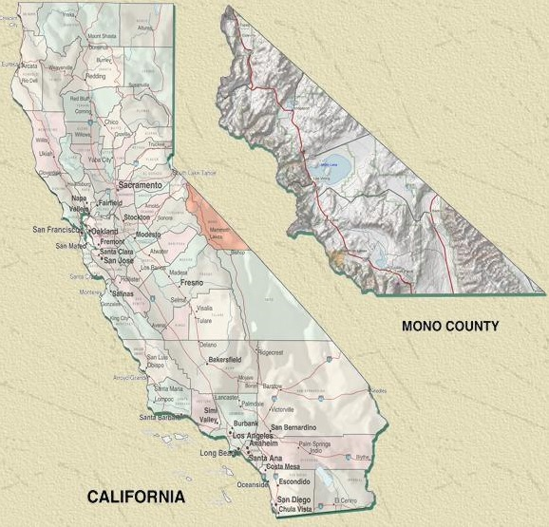
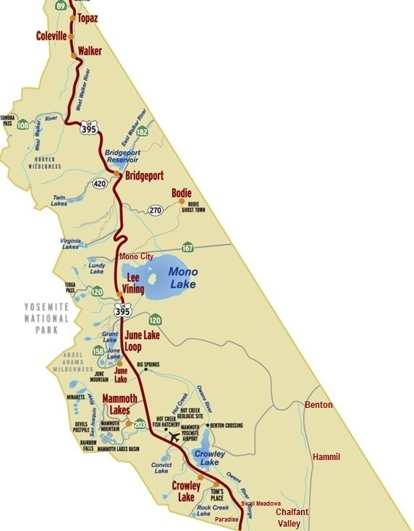

Most residents of Mono County live at elevations between 5,000 to 8,500 feet, with the center of the town of Mammoth Lakes at an elevation of approximately 7,880. Winters are often long and harsh with occasional road closures and summers are brief. Within the county, near the Town of Mammoth Lakes is Mammoth Mountain Ski Area, a popular winter vacation site and one of the top skiing/snowboarding destinations in California. During the 2016/2017 season, snowfall at the ski area’s Main Lodge hit a record 618 inches (over 51 feet) of snow.

Residents primarily earn their livelihood through government service, service industry jobs, and retail trades related to tourism and agriculture. Several of Mono County’s communities are year-round resorts and include a number of multi-million dollar homes belonging to second homeowners. However, many year-round residents struggle to make ends meet, often having more than one job.

Schools for the County are located in Coleville, Bridgeport, Lee Vining, Benton, and Mammoth Lakes, each 25-45 miles from the next. Mono County has two school districts: Mammoth Unified and Eastern Sierra Unified.

According to 2019 Census statistics, the total population of Mono County is 14,444 a slight increase since the 2010 Census. Other than Mammoth Lakes, which has a year-round population of approximately 8,000, the remainder of the county consists of small communities ranging in population from less than 300 to about 1,200 people. To illustrate the vastness of the county, there are approximately 4.6 people per square mile.

The ethnic distribution of Mono County is 27.6 percent Hispanic/Latinx 2.9 percent American Indian and Alaska Native, 0.8 percent Black or African American, 1.8 percent Asian, 0.8 percent Native Hawaiian/Other Pacific Islander/Other/Unknown, and 65.3 percent Caucasian. The county is comprised of 46.9% percent female residents and 53.1% percent male residents.

Figure 1 shows populations by counts and percentages categorized by race, Hispanic or Latinx Origin (of any race), gender, and age. race/ethnicity, and gender of the general population. The majority of persons in Mono County are Caucasian and Hispanic/Latinx. There are a comparable number of males (53%) males and females (47%) in the county.

Figure 1
Mono County Residents
By Gender, Age, and Race/Ethnicity
(Population Source: 2010 Census)

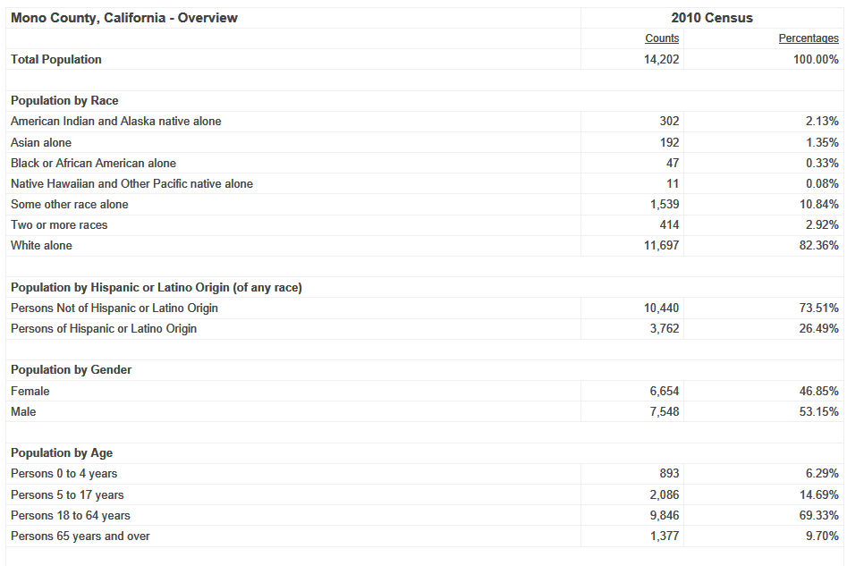

II. Medi-Cal Population Service Needs

Figure 1A below shows the Overall Penetration Rates for the past three years. Calendar Year (CY) 2016 indicates an overall penetration rate that is higher than the State however is lower than the small-rural rate. This rate decreased in CY17 yet was higher again than the State and lower than that of small-rural counties. In CY18, MCBH also had a decreased penetration rate, but higher than the State and a lower penetration rate than the small-rural rates.

Please refer below to Figure 1A. (Source: BHC CalEQRO data).

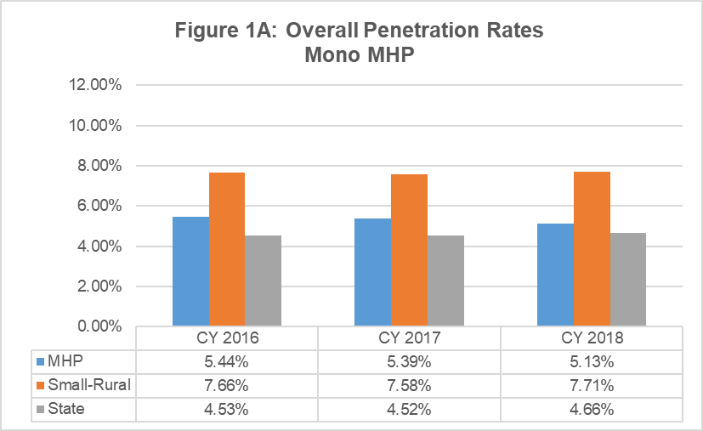
Utilization of Mental Health Services (by age, ethnicity, gender)
For Mono County, the largest group of Medi-Cal Eligibles is the Hispanic/Latinx population. After that, the Caucasian population and then Native American.

The population that is most served by MCBH, in the Medi-Cal Eligible population is the Caucasian population.

Please refer below to Figure 1B. (Source: BHC CalEQRO data).

Table 1B: Medi-Cal Enrollees and Beneficiaries Served in CY 2018,
by Race/Ethnicity
Mono MHP
Race/Ethnicity | Average Monthly Unduplicated  Medi-Cal Enrollees | % Enrollees | Unduplicated Annual Count Beneficiaries Served | % Served
White | 1,287 | 35.9% | 75 | 40.8%
Latino/Hispanic | 1,705 | 47.6% | 86 | 46.7%
African-American | 14 | 0.4% | * | n/a
Asian/Pacific Islander | 30 | 0.8% | * | n/a
Native American | 115 | 3.2% | * | n/a
Other | 436 | 12.2% | 22 | 12.0%
Total | 3,584 | 100% | 184 | 100%
The total for Average Monthly Unduplicated Medi-Cal Enrollees is not a direct sum of the averages above it.
The averages are calculated independently.
CALEQRO PERFORMANCE MEASURES FY19-20 – MONO MHP
(Source: BHC CalEQRO data)

The Hispanic/Latinx penetration rates for MCBH has increased over the past several years, although in CY16 and CY17 the penetration rates areas are just slightly under the small-rural rates. However, in CY18 the penetration rates for MCBH rose above both the State rates and the small-rural rates.

Please refer below to Figure 2A. (Source: BHC CalEQRO data).

III. 200% of Poverty (minus Medi-Cal) population and service needs

Mono County’s per capita income estimate in 2012-2016 was at $31,059 (source: U.S. Census). This is fairly comparable to the statewide per capita income of $31,458.

For median household income, the U.S. Census lists median household income for time period 2012-2016 in Mono County at $58,937. In comparison, the statewide average for this same time period is listed at $63,783. Thus, this data indicates that Mono County’s median household income is, on average, $4,846 less than the statewide average.

The U.S. census for the same time periods indicated above list that 11.5 percent of Mono County residents live in poverty. The median value of owner-occupied housing units is $286,100.

IV. MHSA Community Services and Supports (CSS) population assessment and service needs
Please refer to the FY 19/20 Mental Health Services Act Annual Update, which is attached to this document as Attachment C.

V. Prevention and Early Intervention (PEI) Plan: The process used to identify the PEI priority populations
Please refer to the FY 19/20 Mental Health Services Act Annual Update, which is attached to this document as Attachment C.

Criterion 3: Strategies and efforts for reducing racial, ethnic, cultural, and linguistic mental health disparities

I. Identified unserved/underserved target populations and identified inequities

We know culture plays an essential role in how clients and their families define mental health and respond to the services offered by mental health providers. Cultural competency, and also cultural humility, produces better care and better outcomes for the people we serve. This includes our staff being able to identify cultural differences with each other, community members and consumers. MCBH continually strive to provide information regarding “competency” about cultures that may differ from our own: Hispanic/Latinx persons and how there are cultural differences within this demographic, persons living in poverty, persons attracted to the loner/independent/off-the-grid lifestyle, as well as Native America persons who come from the different reservations in our county, multi-generational families who have lived in this Frontier county, etc.

With competency and humility as our goal, there are a number of obstacles that we continue to face due to the size and nature of our county.

- Staffing: While MCBH has hired more qualified personnel to reflect the County’s culturally and linguistically diverse community, we feel strongly that, when at all possible, our staff ought to mirror the ethnic demographics of our county and our clients. Currently we have no Native American staff members.

- Training: Due to our remote location, and small staff size, paying for, and incentivizing outside trainers who are skilled at cultural competency and/or have knowledge about the culture of the people in Mono County has been difficult in the past.

- Community:
  - Our county is spread over a large geographical area, and the community in the north of our county is very different than that in the south of the community. The services that are provided in Mammoth Lakes, and how we outreach to people in that town has to be very different from how we engage and serve our outlying areas of the county. Outreach to our Native American community has been a barrier for MCBH in the past, and thus is one of our priorities.

II. Identify strategies/objectives/actions/timelines for FY 20-21
The following objectives have been identified to promote the development of culturally and linguistically competent services throughout our organization.

Goal 1: MCBH will provide culturally and linguistically appropriate behavioral health services to improve access for persons who are Native American, Hispanic/Latinx and other race/ethnicity groups; TAY and older adults; veterans and their families; lesbian, gay, bisexual, transgender, questioning, intersex, and two-spirit (LGBTQI2-S) individuals; persons released from jail and their families; and physical disabilities.
- Objective 1a: MCBH will provide informing materials in English and Spanish in our clinics and wellness centers.
- Objective 1b: When appropriate, MCBH will hire and retain diverse or bilingual staff to work in our programs in order to provide services and information to the client and family in their preferred language and preferred cultural setting.
Objective 1c: MCBH will ensure that the crisis line is culturally-sensitive to all persons utilizing these services, and clients receive services in their preferred language.

Current status:
- MCBH continues to provide all informing materials in English and Spanish; in FY 19-20, the department hired five bilingual staff members and one bicultural staff member who is not bilingual. Additionally, MCBH ensures that the crisis line is culturally responsive by staffing it with bilingual staff members. MCBH continually strives to expand the number of services we have available in Spanish. In an effort to continue to improve mental health access for Hispanic/Latino and monolingual Spanish speaking consumers.

Goal 2: MCBH will create a work culture that values justice, equity, diversity, and inclusion through staff cultural competence training, dialogue, and other professional development opportunities.
- Objective 2a: In FY 2020-2021, all MCBH staff will attend three three-hour workshops led by Dr. Jei Africa promoting racial justice, equity, diversity, and inclusion.
- Objective 2b: MCBH will offer at least one training regarding American Indian culture.
- Objective 2c: MCBH will train staff regarding LGBTQA+ related issues on access, stigma, and therapeutic needs.
- Objective 2d: MCBH will host a training around cultural issues and outreach and when working with LGBTQA+ adults and youth within the Hispanic/Latinx community.
- Objective 2e: MCBH staff will participate on the California Behavioral Health Directors’ Association (CBHDA) LGBTQA+ Workgroup and implement best practices around serving this group in the Department.
Current status:
- MCBH has delivered trainings to staff that are culturally appropriate to the LGBTQ+ community, trainings regarding American Indian culture, and training for the Annual Central Valley Latino Conference.
Goal 3: MCBH will provide services in culturally-appropriate and accessible ways. MCBH recognizes that due to cultural and/or other socio-economic barriers that exist within our county, utilizing the public behavioral health system may not be a viable option for some clients and their family members.
- Objective 3a: MCBH will deliver services in the most accessible ways (e.g., telehealth, home, schools, tribal community, senior center, and other rural community locations) when needed and as appropriate.
- Objective 3b: MCBH will provide outreach and engagement with local Tribal community members, including those working in the mental health/substance use disorder profession.
- Objective 3c: MCBH will work closely with local school districts (Eastern Sierra Unified School District and Mammoth Unified School District) to engage youth and TAY in the development of strategies to prevent alcohol and drug abuse and intervene early in the onset of behavioral health issues.
- Objective 3d: MCBH will hold meetings with other agencies and programs to discuss and plan culturally competent services that promote community wellbeing.
Current status:
- Particularly through the work of its Cultural Outreach Committee and Ethnic Services Manager, MCBH is actively working toward each of these objectives. The department strives to provide services in the most accessible ways, though at present is limited by COVID-19. Through the work of our clinical staff and care coordinators, MCBH regularly engages with Tribal community members and the ESM has worked to include several Tribal community members on the COC. Youth are engaged presently through virtual school programming and through the ESM’s work with the Gender Sexuality Alliance. Finally, MCBH’s ESM has become a resource for other community partners and agencies seeking to start conversations about cultural competence, justice, equity, diversity and inclusion in their own organizations. It is MCBH intention that building these partnerships will promote overall community wellbeing.

Goal 4: Considering that the Latinx and Hispanic communities in Mono County have been the most affected by the pandemic in the year of 2020, MCBH will research and respond to the inequities coming to light as a result of COVID-19.
  - Objective 4a: Identify opportunities for collaboration in the Spanish-speaking community (i.e. Latinx/Hispanic community events, etc.) to provide outreach with an emphasis on mental health and wellbeing.
  - Objective 4b: Continue bi-weekly Hispanic/Latinx Engagement Committee Meetings to discuss challenges, barriers, successes, and solutions. (The Hispanic/Latinx Engagement Committee Meeting has met regularly since pandemic started).
  - Objective 4c: Participate in EOC’s process to hire marketing and communications firm that specializes in outreach to Hispanic/Latinx communities around COVID-19.
  - Objective 4d: Through EOC, educate employers and community at large regarding the impact that COVID-19 is having on Hispanic/Latinx community in order to promote an empathetic response.
  - Current status:
- Mono County has contracted with a public firm, BP cubed communication, to effectively support in the outreach efforts to the local Hispanic/Latinx Community on COVID-19. The communication firm is to provide ongoing support for the County meetings and activities related to the pandemic and other key issues.
Goal 5: MCBH will be a leader in justice, equity, diversity, and inclusion (JEDI) trainings and dialogue and will strive to create an anti-racist environment throughout Mono County.
- Objective 5a: MCBH will address a public meeting with Board of Supervisors with Dr. Jei Africa on how to address racism in Mono County and how to develop a culture of anti-racism within the County.
- Objective 5b: MCBH will hold trainings on implicit bias to institutions and agencies in our County - with a focus on upper management at major employers (specifically hospital, MMSA, schools, County, Town) to begin to break down institutional racism.
- Objective 5c: Offer Storytelling: Invite people to share stories of what it's like to live in Mono County as BIPOC . In addition, MCBH has taken initiative on readings about diversity at schools.
- Objective 5d: Include Native Community Members on the COC.
- Objective 5d: Promote JEDI through schools by reading stories and leading discussions about diversity, race, and different cultures/perspectives/experiences.
- Objective 5e: Increase Outreach: broadcast meetings through Facebook and physical gatherings when possible.
Current status as of December 2020:
- A resolution of the Mono County Board of Supervisors recognizing racism as a public health crisis was passed on October 13, 2020. MCBH institutions and agencies in the county have started an Equity committee that meets on a weekly basis and discusses over the topics of Racism, Equity, Diversity & Inclusion.

III. Planning & monitoring of identified strategies/objectives/actions/timelines to reduce mental health inequities: evaluation of FY 19-20 goals & objectives

The goals and objectives below are from the previous CLCP in FY 2019-2020. Progress toward these goals is outlined in the “current status” section after each goal. Through these goals and objectives, MCBH has worked tirelessly to provide culturally-specific services to meet the needs of diverse populations, including peer-driven services. MCBH’s COC has opted to carry over/continue several of the goals and objectives from FY 19-20 into FY 20-21. As a results the goals and objectives outlined below may seem similar to those abov with some similar current status reports. With the addition of a a designated ESM, MCBH hopes to continue to develop and shift our goals and objectives in the next fiscal year.
Goal 1: To provide culturally and linguistically appropriate behavioral health services to improve access for persons who are Native American, Hispanic/Latinx and other race/ethnicity groups; TAY and older adults; veterans and their families; lesbian, gay, bisexual, transgender, questioning, intersex, and two-spirit (LGBTQI2-S) individuals; persons released from jail and their families; and additional cultures.
- Objective 1a: MCBH will provide informing materials in English and Spanish in our clinics and wellness centers.
- Objective 1b: When appropriate, MCBH will hire diverse or bilingual staff to work in our programs in order to provide services and information to the client and family in their preferred language and preferred cultural setting.
- Objective 1c: MCBH will ensure that the crisis line is culturally sensitive to all persons utilizing these services, and clients receive services in their preferred language.

Current Status as of December 2020:
- MCBH continues to provide all informing materials in English and Spanish, hires bilingual staff, and ensures that the crisis line is culturally sensitive. These objectives are central to the work of Mono County Behavioral Health. MCBH continually strives to expand the number of services we have available in Spanish. In an effort to continue to improve mental health access for Hispanic/Latinx and monolingual Spanish speaking consumers, MCBH is committed to recruiting and retaining bilingual and/or bicultural staff. Thirty one percent (31%) of our staff is bilingual/bicultural. Demographically, the highest concentration of bilingual and mono-lingual Spanish speaking consumers reside and work in the town of Mammoth Lakes, the location of our main office. While our staff provide services in the other areas of our County, the majority of staff provide services in Mammoth Lakes. MCBH makes every effort to assign our bilingual staff to any areas that constitute need for culturally-specific services. Our focus is to provide direct services and to create and maintain linkages with other programs to ensure that Hispanic/Latino consumers receive appropriate services.

Goal 2: To create a work climate where dignity and respect are encouraged and modeled so that everyone enjoys equitable opportunities for professional and personal growth.
- Objective 2a: MCBH will provide one four-hour cultural and linguistic competency training for MCBH staff (therapists, case managers, office staff, and administrative staff) each fiscal year.
- Objective 2b: MCBH will sponsor no less than one training regarding American Indian culture (knowing that there are many and a generalization is a better place to begin training than to not do it at all). This training will be for MCBH staff and will include invitations to partnering departments and agencies.
- Objective 2c: MCBH will determine ways to train staff regarding LGBTQIA+ related to access, stigma and therapeutic needs so that all staff have a working knowledge and a level of comfort to provide treatment to this sub-group. Ideas generated will be written and training needs established.
- Objective 2d: MCBH will host a training around cultural issues and outreach and when working with LGBTQIA+ adults and youth and the Hispanic/Latinx community.
- Objective 2e: MCBH will continue its efforts to find training for all staff regarding the "Culture of Poverty in Rural/Remote America."
- Objective 2f: MCBH will provide staff training for the Annual Central Valley Latino Conference, Visalia CA.

Current Status as of December 2020:
- MCBH has delivered trainings to staff that are culturally appropriate to the LGBTQIA+ community, trainings regarding American Indian culture, and training for the Annual Central Valley Latino Conference.

Goal 3: To deliver behavioral health services in collaboration with other community organizations and co-locate services whenever possible, including in diverse community settings (e.g., tribal community, schools, and other rural community locations).
- Objective 3a: MCBH will deliver services in the lmost accessible environment (e.g., home, schools, tribal community, senior center, and other rural community locations) when needed and as appropriate.
- Objective 3b: MCBH will provide outreach and engagement with local Tribal community members, including those working in the mental health/substance abuse profession.
- Objective 3c: MCBH will work closely with local school districts (Eastern Sierra Unified School District and Mammoth Unified School District) to engage youth and TAY in the development of strategies to prevent alcohol and drug abuse and intervene early in the onset of behavioral health issues.
- Objective 3d: MCBH will hold meetings with other agencies and programs to discuss and plan culturally competent services that promote community wellbeing.

Current status as of December 2020:
Due to COVID-19, MCBH is providing all services in a telehealth/virtual environment. This improves access for some clients and restricts it for others. When school is in session, students and families benefit from Spanish-speaking school-based counseling services offered through the North Star Counseling Center. Located in Mammoth Lakes, North Star Counseling Center is a school-based counseling service that targets K-12 youth. The purpose of the North Star Counseling Center is to provide quality, culturally relevant, low cost counseling services to Mono County students and their families. This school-based counseling center focuses on prevention and early intervention strategies and treatments.

The MCBH Cultural Outreach Committee has engaged with members of the Kutzadika ‘ a tribe and Toiyabe tribe on issues related to the stigma, access, and service provision.

Goal 4: To expand upon our Wellness Center by looking into a larger building and a new location.
- Objective 4a: MCBH will research the possibility of a larger Wellness Center building at a new location near the current construction of the government interagency office that will be housing County offices and Town of Mammoth Lakes offices.
- Objective 4b: MCBH will research the possibility of having plumbing and a smart thermostat in the Wellness Center.
- Objective 4c: MCBH will collaborate with Mono County Counsel, Mono County I.T. Department and Mono County Public Works to secure a new location.
- Objective 4d: MCBH will expand upon its current events/activities; providing events, groups and materials at no charge.

Current Status as of December 2020:
- In winter 2019, MCBH executed a lease on a new space for the Sierra Wellness Center in the Town of Mammoth Lakes. This is a larger, centrally located space with both office and lounge space that sits 1.5 blocks away from Mammoth High School and 2.5 blocks away from the MCBH offices. This space has a sink for art supplies and a nearby restroom, as well as a smart thermostat. MCBH was intending to launch a range of new wellness center programming, but achievement of this objective was halted due to COVID-19. During non-pandemic times, the Sierra Wellness Center is home to the Clubhouse Live after school youth program, which was frequently attended by Latinx youth.

Goal 5: To provide the following prospective Socials (prior to the on-set of COVID-19, MCBH hosted a monthly Social in each of the communities below to help promote community connectedness and wellness; in Benton in particular, the monthly social helped promote connection with the members of the Utu Utu Gwaitu Tribe in that community.):
- Bridgeport Socials for 2020 – 12 Socials
  - Prospective Dates (subject to change): 1/15/20, 2/19/20, 3/18/20, 4/15/20, 5/20/20, 6/17/20, 7/15/20, 8/19/20, 9/16/20, 10/21/20, 11/18/20, 12/16/20

- Benton Socials for 2020 – 12 Socials
  - Prospective Dates (subject to change): 1/31/20, 2/28/20, 3/27/20, 4/24/20, 5/29/20, 6/26/20, 7/31/20, 8/28/20, 9/28/20, 10/30/20, 11/20/20, 12/18/20

- Walker Socials for 2020 – aiming for 12 Socials
  - Prospective Dates (subject to change): 1/31/20, 2/28/20, 3/27/20, 4/24/20, 5/29/20, 6/26/20, 7/31/20, 8/28/20, 9/25/20, 10/30/20, 11/20/20, 12/18/20

Current Status as of December 2020:
- MCBH hosted as many of these planned socials as possible until the onset of COVID-19. The Department intends to re-instate community socials once it is safe to do so once again.

Criterion 4: Client/Family Member/Community Committee: Integration of the Committee within the County Mental Health System

The Cultural Outreach Committee (COC) meets every last Friday (4th Friday if calendar permits) of the month and spends a significant amount of time discussing the mental health status of Mono County’s immigrant population and potential outreach options to ensure the health and safety of our very important group of Hispanic/Latinx residents. The Cultural Outreach Committee has also spent significant time addressing the disparities that COVID-19 pandemic has brought up in our community. In the past year, the COC has worked diligently in collaborating with various businesses and agencies and regularly has attendance, participation and alliance with these entities. Lastly, consumer and community involvement is also a contributing part of the COC meetings.

The Cultural Outreach Committee is reflective of the community

The MCBH Ethnic Services Manager (ESM) monitors all activities pertaining to the COC and provides technical support. The ESM is oversees the development of the CCLP and is a member of the Equity Committee; the Equity committee was established after Mono County passed the resolution that addressed mental health as crisis. This committee is to address justice, equity, diversity, and inclusion within the county and community. Also committee is yet to establish meeting dates and time and will follow in January 2021. This structure facilitates communication and collaboration for attaining the goals as set forth in the Cultural and Linguistic Competence Plan (CCP). Plan to reduce disparities, increase capacity, and improve the quality and availability of services.
The Mono County Cultural Outreach Committee works closely to ensure compliance to the Cultural and Linguistic Competence Plan and include recommendations in its CCLP implementation and development. In addition the MCBH Program Manager and a Wellness Center peer attend all COC, QIC, and BHAB meetings (Behavioral Health Advisory Board). The COC will in future participate in MHSA planning processes.
The Cultural Outreach Committee will continue to meet every last Friday of the month and track their activities so that projects, activities and policy issues are reported to the MCBH Program Manager to ensure compliance.
The policies, procedures, and practices that assure members of the Cultural Outreach Committee will be reflective of the diversity of the community, including county management level, line staff, clients, family members from ethnic, racial, and cultural groups, providers, community partners, contractors and other members as necessary.
Cultural Outreach Committee Roster:
- Kasandra Montes- Mono County BH, ESM/Case Manager
- Tajia Rodriguez- Mono County BH, Wellness Center Associate
- Luisana Baires- Mono County BH, Case Manager
- Sandra Villalpando- Mono County BH, Psychiatric Specialist
- Melissa Martinez- Toiyabe Indian Health Project, Psychiatric Specialist
- Wendy Rangel-Guzman- Mono County Social Services, Eligibility Specialist
- Pedro Figueroa- Mono County Social Services, Social Service Aide
- Dirk Solo- Mono County Resident, Community member, LGBTQIA+ Ally
- Juan Rios- Mono County Resident, community member, LGBTQIA+ Ally , business owner
- Jocelyn Sheltraw- Mono Lake Kutzadika Cultural Preservation Chairman
- Charlotte Lange- Mono Lake Kutzadika Cultural Preservation Chairman
Leadership
The COC is led by two Co-Chairs elected annually by members of the Committee.; there are 12 meetings thorough the year.
The roles and responsibilities of the Co-Chairs include:
- Facilitate all meetings
- Engage members in Committee discussions
- Collaborate with the COC in the development of meeting agendas
- Appoint ad-hoc subcommittees as needed
- Communicate the focus of the COC activities and recommendations made to diverse MCBH entities

Event | Number of Attendees | Name of Attendees | Length of meeting | Date
Cultural Outreach Committee | 13 | Robin Roberts  Amanda Greenberg  Kasandra Montes  Sofia Flores  Sal Montanez  Tajia Rodriguez  Sandra Villalpando  Melissa Martinez  Wendy Guzman  Pedro Figueroa  Jocelyn Sheltraw  Charlotte Lagne  Dirk Solo | 60 minutes | 7/10/2020
Cultural Outreach Committee | 9 | Kasandra Montes  Amanda Greenberg  Sandra Villalpando  Luisana Baires  Tajia Rodriguez  Melissa Martinez  Wendy Guzman  Pedro Figueroa  Dirk Solo | 90 minutes | 8/05/2020
Cultural Outreach Committee | 8 | Kasandra Montes  Amanda Greenberg  Sandra Villalpando  Luisana Baires  Tajia Rodriguez  Melissa Martinez  Dirk Solo  Juan Rios | 90 minutes | 9/25/20
Cultural Outreach Committee | 6 | Kasandra Montes  Amanda Greenberg  Sandra Villalpando  Melissa Martinez  Tajia Rodriguez  Dirk Solo | 90 minutes | 10/30/20
Cultural Outreach Committee | 6 | Kasandra Montes  Amanda Greenberg  Melissa Martinez  Tajia Rodriguez  Wendy Guzman  Dirk Solo | 90 minutes | 11/20/20
Cultural Outreach Committee | 12 | Kasandra Montes  Amanda Greenberg  Sandra Villalpando  Luisana Baires  Tajia Rodriguez  Melissa Martinez  Wendy Guzman  Pedro Figueroa  Dirk Solo  Juan Rios  Jocelyn Sheltraw  Charlotte Lagne | 90 minutes | 12/18/20

Criterion 5: Culturally Competent Training Activities (2019-2020)

MCBH is committed to embedding cultural competence and cultural humility into all training activities within the agency and to the community.

In addition, the ESM attends regular webinar trainings on topics related to cultural competence. All webinar opportunities are distributed to MCBH staff members and community partners in order to increase their education, awareness and skills around all elements of culture.

This section describes cultural competence training for staff and contract providers, including training in the use of interpreters, in 2019. (through 2020)

List of internal training and staff attendance by function:
  - Administration/management;
  - Direct services: MHP’s staff;
  - Direct services: contactors;
  - Support services; and,
  - Interpreters.

Training Event | Number of Attendees | Attendees by Function | Date
Mental Health Assessment Training - Bio/Psych/Social, Case Coordination + Case Coordination/Rehab Aid document | 7 | Behavioral Health Services Coordinator  Case Manager I (2)  Case Manager III  Clinical Supervisor  Psychiatric Specialist II  QA/QI Coordinator | 1/4/2019
LGBTQ Training: First Impressions of LGBTQ People | 11 | Addictions Specialist III  Behavioral Health Services Coordinator Case Manager I (2)  Case Manager III  Clinical Supervisor  Fiscal & Technical Specialist III  Office Assistant I  Psychiatric Specialist I  Psychiatric Specialist II  Psychiatric Specialist III | 5/2/2019
CPPP Training | 9 | Addictions Specialist III  Alcohol and Drug Counselor II  Clinical Supervisor  Fiscal & Technical Specialist III  Mental Health Services Act Coordinator  Office Assistant I  Psychiatric Specialist I  Psychiatric Specialist II  Psychiatric Specialist III | 9/5/2019
In-Service- “Grief” | 14+ | Addictions Specialist III  Behavioral Health Services Coordinator Case Manager I  Case Manager III (2)  Clinical Supervisor  Fiscal & Technical Specialist III  Office Assistant I  Psychiatric Specialist I  Psychiatric Specialist II  Psychiatric Specialist III | 9/1/20
LGBTQIA+ Competence Training | 14+ | Addictions Specialist III  Behavioral Health Services Coordinator Case Manager I (2)  Case Manager III  Clinical Supervisor  Fiscal & Technical Specialist III  Office Assistant I  Psychiatric Specialist I  Psychiatric Specialist II  Psychiatric Specialist III | 9/8/20
In-Service- “Small town boundaries” | 14+ | Addictions Specialist III  Behavioral Health Services Coordinator Case Manager I (2)  Case Manager III  Clinical Supervisor  Fiscal & Technical Specialist III  Office Assistant I  Psychiatric Specialist I  Psychiatric Specialist II  Psychiatric Specialist III | 10/6/20

List of external training provided through outside agencies/resources other than the County’s internal training process; and staff attendance by function:
Training Event | Number of Attendees | Attendees by Function | Date
Gathering of Native Americans (GONA) Facilitator Training. [Cultural Competence Training]  Historical Trauma Training | 14 | Addictions Specialist III  Alcohol and Drug Counselor II  Behavioral Health Services Coordinator  Case Manager I  Case Manager III  Clinical Supervisor  Director  Mental Health Services Act Coordinator  Office Assistant II  Psychiatric Specialist I (2)  Psychiatric Specialist II  Psychiatric Specialist III  QA/QI Coordinator | 1/31/2019
Eastern Sierra Strengths-Based Learning Collaborative - Session #5, Day #1. Partnership with Inyo County and Alpine County. Two-year learning collaborative (clinical change/systems change). Focuses on Strengths Model; evidence-based | 15+ | Addictions Specialist III  Alcohol and Drug Counselor II  Behavioral Health Services Coordinator  Case Manager I (2)  Case Manager III  Clinical Supervisor  Director  Fiscal & Administrative Services Officer  Fiscal & Technical Specialist III  Psychiatric Specialist I (3)  Psychiatric Specialist II  QA/QI Coordinator  Staff from MCBH North Star Center  Mono County Probation Department (2)  Mono County Social Services (2) | 2/6/2019
Eastern Sierra Strengths-Based Learning Collaborative - Session #5, Day #2. Partnership with Inyo County and Alpine County. Two-year learning collaborative (clinical change/systems change). Focuses on Strengths Model; evidence-based | 15+ | Addictions Specialist III  Alcohol and Drug Counselor II  Behavioral Health Services Coordinator  Case Manager I (2)  Case Manager III  Clinical Supervisor  Director  Fiscal & Administrative Services Officer  Fiscal & Technical Specialist III  Psychiatric Specialist I (3)  Psychiatric Specialist II  QA/QI Coordinator  Staff from MCBH North Star Center  Mono County Probation Department (2)  Mono County Social Services (2) | 2/7/2019
Eastern Sierra Strengths-Based Learning Collaborative - Session #6, Day #1. Partnership with Inyo County and Alpine County. Two-year learning collaborative (clinical change/systems change). Focuses on Strengths Model; evidence-based | 15+ | Addictions Specialist III  Alcohol and Drug Counselor II  Behavioral Health Services Coordinator  Case Manager I (2)  Case Manager III  Clinical Supervisor  Director  Fiscal & Administrative Services Officer  Fiscal & Technical Specialist III  Psychiatric Specialist I (3)  Psychiatric Specialist II  QA/QI Coordinator  Staff from MCBH North Star Center  Mono County Probation Department (2)  Mono County Social Services (2) | 4/10/2019
Eastern Sierra Strengths-Based Learning Collaborative - Session #6, Day #2. Partnership with Inyo County and Alpine County. Two-year learning collaborative (clinical change/systems change). Focuses on Strengths Model; evidence-based | 15+ | Addictions Specialist III  Alcohol and Drug Counselor II  Behavioral Health Services Coordinator  Case Manager I (2)  Case Manager III  Clinical Supervisor  Director  Fiscal & Administrative Services Officer  Fiscal & Technical Specialist III  Psychiatric Specialist I (3)  Psychiatric Specialist II  QA/QI Coordinator  Staff from MCBH North Star Center  Mono County Probation Department (2)  Mono County Social Services (2) | 4/11/2019
Protective Factors Framework: Parental Resilience and Social Connections | 5 | Behavioral Health Services Coordinator  Case Manager I  Case Manager III  Psychiatric Specialist I  Psychiatric Specialist II | 4/12/2019
Severe Mental Health Conditions Workshop + Discussion/Case Consultation. Topics covered: Crisis, working with people in the field, “why won’t s/he take her medications?", co-occurring disorders, what recovery looks like, plus other mental health topics | 12 | Alcohol and Drug Counselor II  Case Manager I (2)  Case Manager III  Clinical Supervisor  Director  Fiscal & Technical Specialist III  Office Assistant II  Psychiatric Specialist I (2)  Psychiatric Specialist II  Psychiatric Specialist III | 4/26/2019
Strengthening the Roots, Central Valley Latino Conference, Visalia CA, 9/19/2019 through 9/20/2019. This 7th Annual Central Valley Latino Conference is a Statewide two-day gathering of fellow therapists, treatment counselors, social workers, educators, administrators, and community workers in the Latino community. Two Keynote Speakers and 25 Workshop Presenters address Cultural Competency and Evidence Base Practices. Mental Health - Behavioral Health - AOD/Substance Abuse- Violence/Criminal Justice - Mindfulness - Indigenous Teachings – LGBTQ | 3 | Psychiatric Specialist III  Case Manager I  Office Assistant II | 9/19/2019 & 9/20/2019
Child Abuse and Culture - Cultural Competency Course | 1 | Psychiatric Specialist I | 9/19/2019
Dr.Jei Africa Training(6)- Diversity, Inclusion, Equity | 14+ | Addictions Specialist III  Behavioral Health Services Coordinator Case Manager I (2)  Case Manager III  Clinical Supervisor  Fiscal & Technical Specialist III  Office Assistant I  Psychiatric Specialist I  Psychiatric Specialist II  Psychiatric Specialist III | 10/26/20

Criterion 6: County’s commitment to a growing multicultural workforce: hiring and retaining cultural and linguistically competent staff

As of December 2020, MCBH is experiencing a shortage of clinical staff similar to the one described in the Workforce Needs Assessment in the FY 18/19 MHSA Annual Update, which is attached. (See Attachment D). This document includes comparisons of staff to Mono County’s general population and client population. The department remains committed to recruiting and retaining culturally and linguistically competent staff, particularly staff who are bilingual English-Spanish speakers.

Despite the limitations of working in an isolated, rural community, MCBH encourages ongoing education and training in an effort to “grown our own.” MCBH continues to offer Masters in Social Work and Marriage and Family Therapist Interns opportunities to earn their hours toward licensure within the department. Additionally, the department has a long operated a loan assumption program to help attract and retain staff members in hard-to-fill positions. In FY 20-21, MCBH is working with the Central Workforce Education and Training (WET) Regional Partnership and the Office of Statewide Health Planning & Development (OSHPD) to maximize funding for this and other workforce-related programs.

Solutions to the retention of workforce within MCBH are currently undergoing analysis to determine if what MCBH is currently doing to promote workforce education and training is sufficient. The department plans to do this through exit interviews, stay interviews, and other similar methods. As mentioned in Criterion 5, MCBH is also committed to training staff in cultural competence and in offering culturally-relevant professional development opportunities to staff through such activities as the Annual Central Valley Latino Conference. Additionally, MCBH addresses staff requests for specific trainings on a regular basis. Additionally, staff are allowed, and encouraged, to expand the scope of service in which they specialize using methods that work for them on an individual basis as long as the impact to service delivery remains positive.

At this time, the County’s technical assistance needs related to this Criterion are being met through a combination of work with Dr. Jei Africa; Dr. Beth Cohen, an organizational psychologist; the Central Regional WET Partnership; and the California Behavioral Health Directors’ Association.

Criterion 7: Language Capacity

I. Increase bilingual workforce capacity
Mono County recognizes the need for bilingual language skills or specialized communication skills to improve consumer experience and reduce cultural/linguistic disparities. Thus, we continue to implement a Bilingual Pay Differential, which is intended to be an incentive for bilingual staff to utilize their skills and for us to leverage resources. All of our bilingual staff must successfully pass a merit exam to determine that they meet the requirements to be considered bilingual.
- We have allocated dedicated resources for interpreter services (Cesco Linguistic Company) in addition to bilingual staff, there are currently 8 bilingual staff members available as interpreters.
- For further information, please see the Mental Health Services Act 18/19 Annual Updated (Attachment D), which includes the Workforce Needs Assessment, and the MHSA 19/20 Annual Update (Attachment C) WET section, which includes MCBH’s strategies for recruiting and retaining bilingual staff members.

II. Limited English Proficiency
(Provide services to persons who have Limited English Proficiency (LEP) by using interpreter services and provide services to all LEP clients not meeting the threshold language criteria who encounter the mental health system at all points of contact)
As outlined in Attachment A: Limited English Proficiency Services Policy and Procedure:
MCBH will assist beneficiaries in accessing services including, but not limited to, the beneficiary brochure required by Section 1810.360(c), materials explaining the beneficiary problem resolution and fair hearing processes required by Section 1850.205(c)(1), and mental health education materials used by the MHP, in threshold languages, based on the threshold languages in the county as a whole.
- When consumers present by telephone or walk-in and need information or request services in a language other than English, reception staff will first attempt to identify the consumer’s primary language using language cards
- Staff will then attempt to locate a staff member who speaks that language to provide or take information. If there is not a staff member available who speaks the client’s language, the Language Line or TTY service will be used for interpretation
- If a caller does not speak English, staff will utilize the Language Line Solutions Line on a conference call for interpretation of other languages as needed.
- Mono County provides a statewide, toll-free telephone number 24 hours a day, 7 days per week that provides adequate TTY/TDD or Telecommunications Relay Services. For TTY/TDD services, Mono County uses Sprint California Relay Services. To access the TTY/TDD services call 1-888-877-5379 for English and 1-888-877-5381 for Spanish.

III. Provide bilingual staff and/or interpreters for the threshold languages at all points of contact
- Two of our staff members alternate the 24/7 Access Line. Both of those staff members are bilingual in Spanish and bicultural.
- Bilingual/bicultural staff are available to assist in our office and are able to communicate with any caller who speaks Spanish.
- New clients are offered an assessment with a Spanish speaking interpreter, whenever possible.
- Throughout the department, information is posted and provided in both English and Spanish
- Bulletins regarding the availability of interpreter services and the language line are posted throughout the MCBH website.
- Our 24/7 Access Log includes a field to record a client’s language and also a field for a need for an interpreter.
- Currently, we have two policies in place that outline the requirements and processes for meeting a client’s request for language assistance. Please see Attachments A and B and E.

IV. Required translated documents, forms, signage, and client informing materials
- All informing materials, including the intake packet and medication consents are provided in both English and Spanish.
- Our EHR includes primary language at the top of the client profile.
- Preferred language is asked as part of the client registration.
- Consumer Perception Surveys are offered in all threshold languages (English and Spanish)

Criterion 8: Adaptation of Services

I. Client driven/operated recovery and wellness programs
Prior to COVID-19, MCBH planned to host a Latino community event every other month facilitated entirely in Spanish. For the last two-three years, this event has been successfully held in a safe atmosphere and culturally competent environment; designed to engage the Hispanic/Latinx consumers and community, reduce mental health stigma, and serve as a space to talk about mental health-related issues as well as a diverse range of other topics. These events will be 100% in Spanish. Identified barriers that will be addressed include stigma towards mental health and substance use services, parenting, child rearing, acculturation, and trust between community and agencies. For the past few years, there have been twelve Hispanic/Latinx forums/events with each event improving in popularity and in attendance. MCBH has experienced significant success with these community wellness forums and will continue to expand and improve these events. Free food is also available at these events.
Despite the limitation placed on these activities due to COVID-19, our staff members have provided wellness activities virtually, through Zoom or Facebook Live on the Mono County Behavioral Health Department Facebook page. At least 30% of posts are in Spanish and since COVID-19, our followers have increased from approximately 60 to 943. This adaptation in services was prioritized since members of the local Hispanic/Latinx community report high rates of Facebook utilization.
Additionally, MCBH recently hired a peer to serve as a Wellness Center Associate in our outlying areas. This new member of our staff with a diverse background is operating wellness programming that appeals to a broad audience.
MCBH also provides Spanish language mandated services, including Batterers’ Intervention and Driving Under the Influence.

II. Responsiveness of mental health services
Some of our methods for informing clients of culturally competent services and providers include: Flyer circulation via public posting locations including, but not limited to: MCBH lobbies, Mammoth Lakes Public Library, Flores Family Day Care, La Tiendita, Espacio II, La Carniceria, Delicious Kitchen Restaurant, Mono County Social Services board, Mono County Superior Court, Laundromats, tabling at Health Fairs and other community events, Mammoth Lakes Post Office, etc.; via email to other county departments and agencies; Spanish Facebook page; Spanish section of Mono County Behavioral Health website; telephone calls to individuals; and “word-of-mouth” throughout the community.

Spanish Website and Facebook page:
- https://www.monocounty.ca.gov/behavioral-health/page/servicios-en-español
- https://www.facebook.com/saludmentalmonocounty/

Individuals who staff our 24/7 Access Line are trained to be familiar with the culturally-competent services that we offer and are able to provide interpreter services or link clients to language assistance services as needed.

Mono County Behavioral Health has several informing materials, brochures, and postings in our lobbies (in English and Spanish) that highlight available services, including culturally-specific services. In addition, informing materials inform clients of their right to FREE language assistance, including the availability of interpreters. Informing materials are offered to clients at intake and are also available in our lobbies and both wellness centers in the county.

A Provider List is available to clients which lists provider names, population specialty (children, adult, veterans, LGBTQI2-S, etc.), services provided, language capability, and whether or not the provider is accepting new clients. This list offered to clients upon intake and is available in our lobbies and both wellness centers. The Provider List is also available on our website in both Spanish and in English for viewing and/or downloading. The Provider List is regularly updated
Visit: https://monocounty.ca.gov/behavioral-health/page/resources

All of our Front Office staff are bilingual and bicultural and are able to assist Spanish speaking consumers immediately. Should a consumer require another language besides Spanish or English, Front Office staff are familiar with the use of Language Line Solutions.

MCBH has also assessed factors that may create barriers for diverse populations to access services and created plans to increase access. These include extended hours from 8am to 5pm, 7 days per week; building a new office space that is ADA compliant; and pursuing a co-located office in a planned affordable housing and permanent supportive housing development in the center of Mammoth Lakes. Finally, MCBH increases access for members of the County’s most rural communities, as well as its Native American residents in those communities by hosting or operating wellness programming in those communities.

III. Quality of Care: Contract Providers
MCBH does not have any contracted mental health providers.

IV. Quality Assurance
At this time, MCBH collects such outcome measures as the PHQ-9, GAD-7, CANS, and ACEs from clients. As part of the Department’s ongoing racial equity training with Dr. Jei Africa, staff are participating in a brief pre/post-test regarding their understanding of cultural competence and comfort having such conversations with fellow staff members.
In terms of the process for reviewing grievances and appeals related to cultural competency Mono County Behavioral Health is committed to addressing issues regarding cultural competency grievances and appeals in an expedient and appropriate manner. The department is also committed to providing several avenues to file an issue:
- Ensuring assistance is available, if needed, for the client / family member / provider / community member to file their issue; and
- Honoring the Issue Filer’s desire for anonymity; and
- Contact with MCBH’s contracted Patient Rights Advocate.
MCBH will follow all protocols as outlined in our “Beneficiary Grievance and Appeal Process” policy and procedure when cultural issues arise.

