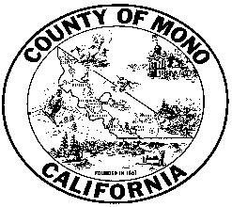

**MONO COUNTY BEHAVIORAL HEALTH DEPARTMENT**



**P. O. BOX 2619 MAMMOTH LAKES, CA 93546 (760) 924-1740 FAX: (760) 924-1741**

Meeting Agenda: Behavioral Health Advisory Board

Monday December 14, 2020 Agenda 3:00-4:30

Zoom meeting:

Link: https://monocounty.zoom.us/j/7609241741

Call in: +1 669 900 6833 Meeting ID: 760 924 1741

1. Public Comment
2. Introductions
3. Approval of minutes from November meeting
4. Behavioral Health Department Updates
   1. Coleville/Walker fire response
   2. Covid-19
   3. Staff changes
   4. Cultural Outreach Committee
   5. School Outreach
   6. Housing Update

V. Data notebook

1. Community Program Planning Session. Top Community needs
2. Board Member Reports
3. Confirm dates of 2021 meetings: Feb. 8, April 12, June 14, August 9, October 10, December 13.

___________________________________________________________________

In compliance with the Americans with Disabilities Act, anyone who needs special assistance to attend this meeting can contact the Behavioral Health Department at 760-924-1740 within 48 hours prior to the meeting in order to ensure accessibility (see 42 USCS 12132, 28CFR 35.130).