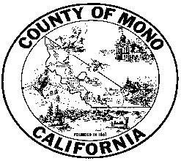

**MONO COUNTY BEHAVIORAL HEALTH DEPARTMENT**



**P. O. BOX 2619 MAMMOTH LAKES, CA 93546 (760) 924-1740 FAX: (760) 924-1741**

Meeting Agenda: Behavioral Health Advisory Board

Monday October 19, 2020 Agenda 3:00-4:30

Zoom meeting:

Link: https://monocounty.zoom.us/j/7609241741

Call in: +1 669 900 6833 Meeting ID: 760 924 1741

1. Public Comment
2. Introductions
3. Approval of minutes from June, and September meetings
4. Behavioral Health Department Updates
   1. Covid-19 Response
   2. Logo
   3. Cultural Outreach Committee
   4. School Outreach
   5. Inclusion of the Behavioral Health Permanent Supportive Housing project in Phase 1 of The Parcel
5. Letter of support for the project to the Town Council: action item
6. Continuum of Care Homelessness Plan: potential action
7. Advisory Board 2020 Goals/Activities Discussion
8. Board Member Reports
9. Confirm date and adjourn to next meeting. December 14, 2020

___________________________________________________________________

In compliance with the Americans with Disabilities Act, anyone who needs special assistance to attend this meeting can contact the Behavioral Health Department at 760-924-1740 within 48 hours prior to the meeting in order to ensure accessibility (see 42 USCS 12132, 28CFR 35.130).