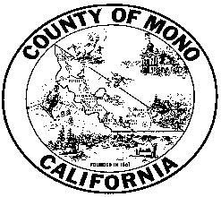

**MONO COUNTY BEHAVIORAL HEALTH DEPARTMENT**



**P. O. BOX 2619 MAMMOTH LAKES, CA 93546 (760) 924-1740 FAX: (760) 924-1741**

Meeting Agenda: Behavioral Health Advisory Board

September 14, 3:00-4:30

Zoom meeting:

Link: https://monocounty.zoom.us/j/7609241741

Call in: +1 669 900 6833 Meeting ID: 760 924 1741

1. Public Comment
2. Introductions
3. Approval of minutes from June, 2020 meeting
4. Behavioral Health Department Update
   1. Covid-19 Response
   2. Housing
   3. Logo
   4. Cultural Outreach Committee
5. Upcoming Board Training Opportunities
   1. Anti-Racism Training Mono County BOS: September 15 2 pm
   2. CalBHBC.org: Oct 1-2
6. Advisory Board 2020 Goals/Activities Discussion
7. Board Member Reports
8. Confirm date and adjourn to next meeting.

___________________________________________________________________

In compliance with the Americans with Disabilities Act, anyone who needs special assistance to attend this meeting can contact the Behavioral Health Department at 760-924-1740 within 48 hours prior to the meeting in order to ensure accessibility (see 42 USCS 12132, 28CFR 35.130).