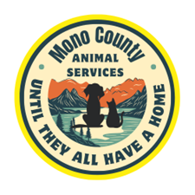

County of Mono

Department of Animal Services

P. O. Box 263

Bridgeport Ca 93517

animal@mono.ca.gov

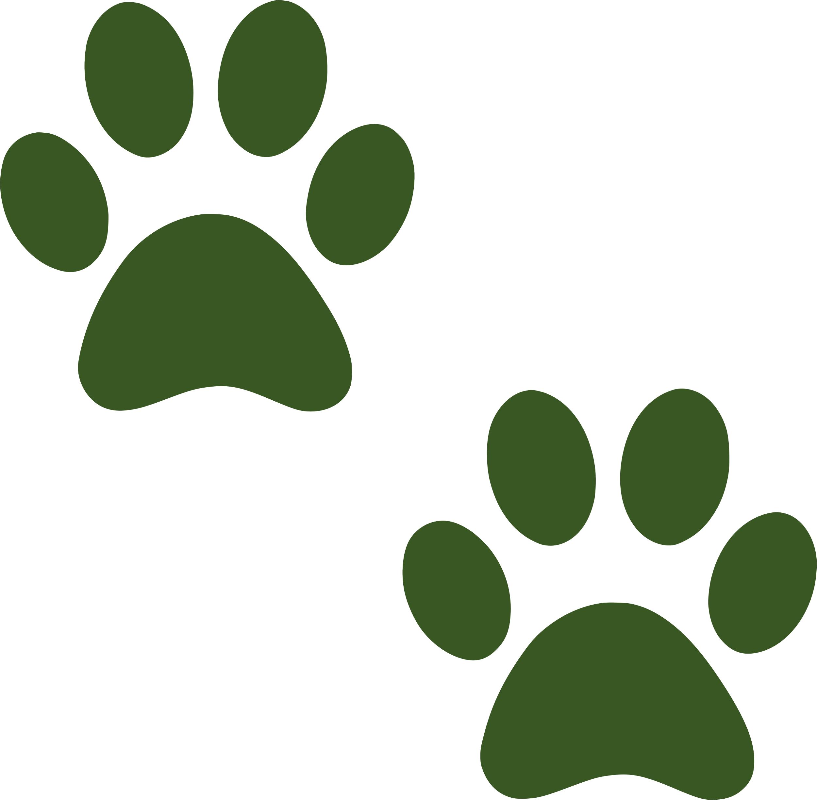

Low Cost Spay/Neuter Voucher Application

Thank you for your interest in spaying/neutering your pet! This program is designed to assist pet owners who reside in Mono County with low-cost options for spay/neuter of beloved pets. You may submit the voucher via email, mail or drop off at any of our shelters.

Please complete the following information below and a voucher will be issued upon approval.

Owner Information:

First and Last Name: Click or tap here to enter text.

Physical Address: Click or tap here to enter text. P. O. Box:

City: Click or tap here to enter text. State:Click or tap here to enter text. Zip:Click or tap here to enter text.

Phone:Click or tap here to enter text.

Email:Click or tap here to enter text.

I am at least 18 years of age and the legal owner of this animal: Y/N Click or tap here to enter text.

If you are applying for a low-cost voucher for a dog, you must have a current Mono County dog license.

Pet Information

Dog License Number: Click or tap here to enter text.

Or Cat

Name:Click or tap here to enter text. Breed:Click or tap here to enter text. Gender:Click or tap here to enter text. Age:Click or tap here to enter text. Color:Click or tap here to enter text.

I can transport my pet (Please Initial): Click or tap here to enter text.

If you are transporting your pet once you receive the voucher you will schedule an appointment with the vet, please advise that you have been issued a voucher through Mono County. Surgery instructions will be provided with your voucher.

I would like to request transportation for my pet (Please Initial): Click or tap here to enter text.

A Mono County Officer will contact you and schedule your surgery and arrange for transport. It is possible that your pet may need to spend the night before surgery at the shelter. Once your pet is scheduled for the vet you will need to contact the vet and provide your credit card number for your share of the cost. Please be aware that your pet will not receive surgery if the vet has not received your payment ahead of the scheduled surgery.

Initial I agree and understand the following: Click or tap here to enter text.

By choosing this option you understand that transporting and sheltering can be risky. Your animal my sustain injuries in transport or illness in the shelter. By choosing this option, you are agreeing to not hold Mono County Animal Services liable for any damages to your pet while your pet is in their care and custody.

Costs

This program is a shared cost program; Mono County pays a portion of the surgery ONLY to lower the cost for the owner. **Any complications from pregnancy, cryptorchidism, pain medications or vaccinations will be applied to the owner’s portion of the cost.**

|  |  |  |  |
| --- | --- | --- | --- |
| Dog Neuter |  | Dog Spay |  |
| County Pays | Owner Pays | County Pays | Owner Pays |
| $123 | $124 | $137 | $138 |
|  |  |  |  |
| Feline Neuter |  | Feline Spay |  |
| County Pays | Owner Pays | County Pays | Owner Pays |
| $57 | $58 | $121 | $122 |